COINS-Ebay-2012 May

**PERGAMON 100BC Asclepius & Snake Quality Original Authentic Ancient Greek Coin**

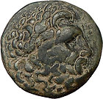

[PERGAMON 100BC Asclepius & Snake Quality Original Authent...](http://www.ebay.com/itm/350526972087?ssPageName=STRK:MEWNX:IT&_trksid=p3984.m1439.l2649) (350526972087)

Sale date: 05/08/12

Tracking number: [9402111201080509906178](javascript:;)

Estimated Delivery: 05/14/12

$150.00

$375.00

**(60% off)**

+ $4.50

shipping

**Paid with PayPal on May 08, 2012.**

**Shipped 05/08/12**

**Feedback not left**

**Positive feedback received**

|  |
| --- |
| [**View order details**](http://payments.ebay.com/ws/eBayISAPI.dll?ViewPaymentStatus&transId=341292006022&ssPageName=STRK:MEWNX:VPS&itemid=350526972087&_trksid=p3984.m1439.l2673) |
| [Leave feedback](http://feedback.ebay.com/ws/eBayISAPI.dll?LeaveFeedbackShow&useridto=highrating_lowprice&item=350526972087&transactID=341292006022&ssPageName=STRK:MEWNX:LF&_trksid=p3984.m1439.l2665) |
| [More actions](javascript:;) |

**CONSTANTINE I "The Great" 307-337 AD Roman Bronze Coin Campgate**

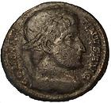

[CONSTANTINE I "The Great" 307-337 AD Roman Bronze Coin Ca...](http://www.ebay.com/itm/170838584636?ssPageName=STRK:MEWNX:IT&_trksid=p3984.m1439.l2649) (170838584636)

Sale date: 05/08/12

Tracking number: [RR212780202HU](javascript:;)

Estimated Delivery: 05/24/12 - 06/07/12

**CONSTANTINE I "The Great" 307-337 AD Roman Bronze Coin Campgate(d37)  
  
Diameter: 19 mm  
Weight: 3,0 g**

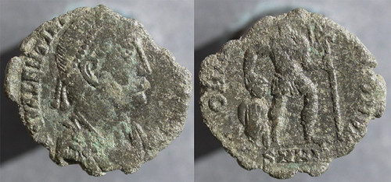

Ancient Roman Coin

Bronze (AE3) Nummis of Valentinian I, A.D. 364-375.

Nicomedia mint, A.D. 364-367.

RIC 9(a) (rare). 16 mm, 1.5 g.  
  
﻿Obverse: D N VALENTINI-ANVS P F AVG.  
Reverse: GLORIA RO-MANORVM - Emperor advancing right, carrying standard with Chi-Rho (early Christian symbol) and dragging captive.  
SMH[A?] in exergue.

The declaration by his troops of Valentinian I as emperor upon the death of Jovian marked the end of the Constantine dynasty and the beginning of the Valentinian dynasty. He fought many successful battles against barbarian invaders in the West and gave control of the Eastern half of the empire to his younger brother, Valens.

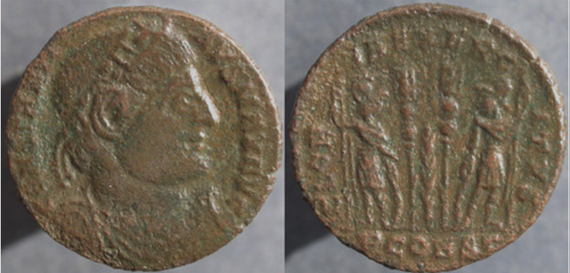

Ancient Roman Coin

Bronze (AE3) Nummis of Constantine I ("the Great"), A.D. 307-337.

Arles (Arelate) mint, A.D. 332.

RIC 358. 18 mm, 2.2 g.  
  
﻿Obverse: CONSTANTI-NVS MAX AVG.  
Reverse: GLOR-IA EXERC-ITVS - Two soldiers, standing, holding spears and resting hands on shields; two standards between them.  
PCONST in exergue; Laurel branch in field (between standards).

Of all Rome’s emperors, Constantine I, known today as Constantine the Great, probably had the greatest impact on Western civilization. He converted to Christianity and made it the favored religion of the empire, ending centuries of persecution of Christians and allowing the Catholic Church to become a major political influence. His decision to move the capital of the Empire east to Byzantium (renamed Constantinople) allowed the Empire to continue for another 1,000 years after the collapse of Rome in the late 5th century.

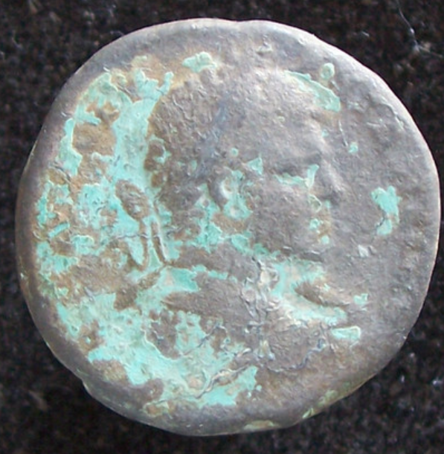 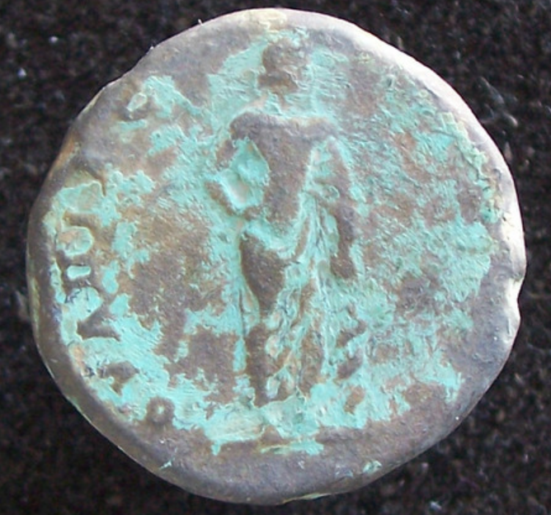

# ANCIENT ROMAN COIN - AE28 CARACALLA - ASKLEPIOS

**CARACALLA**

**Marcus Aurelius Antoninus**

**Emperor 211 - 217**

**\*\*\*\*\*\*\*\*\***

**28 mm  Dia.  17.51 g**

**Provincial issue, possibly from Serdica.**

**Reverse shows a standing figure ( Asklepios / Aesculapius? )**

**right hand on hip, left holding snake entwined rod**

**Big, heavy coin.**

**Nice old bronze toning.**

**\*\*\*\*\*\*\*\*\***

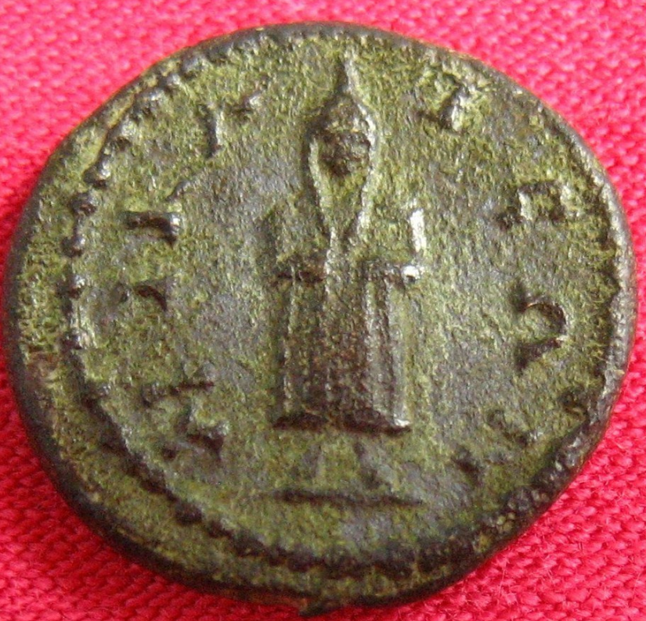 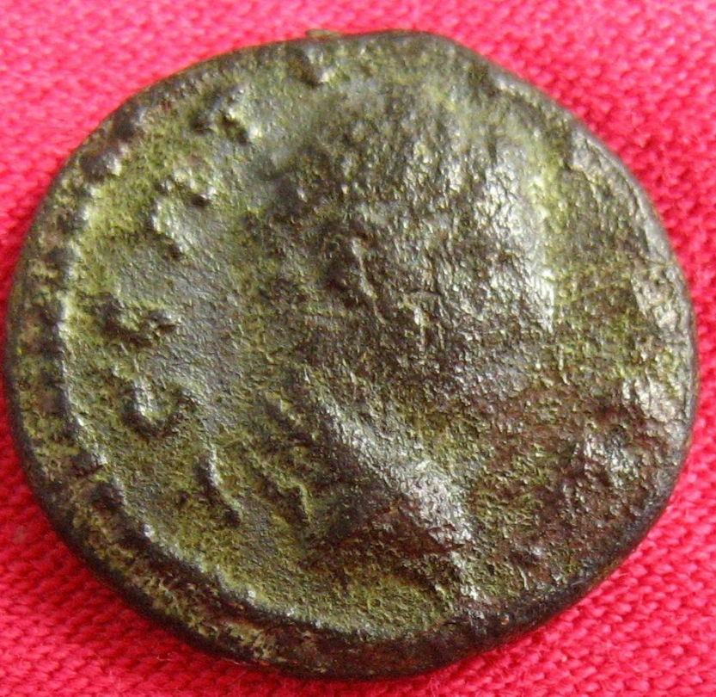

Septimius Severus Provincial Coin 17mm

Telesephoros

Asklepios

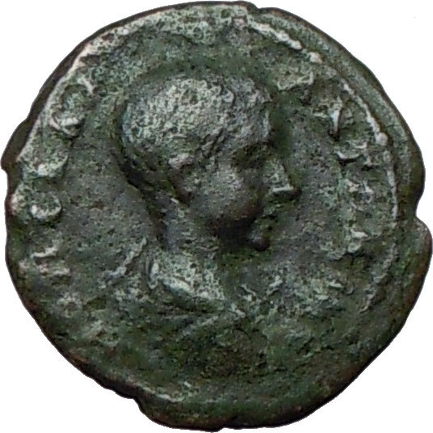 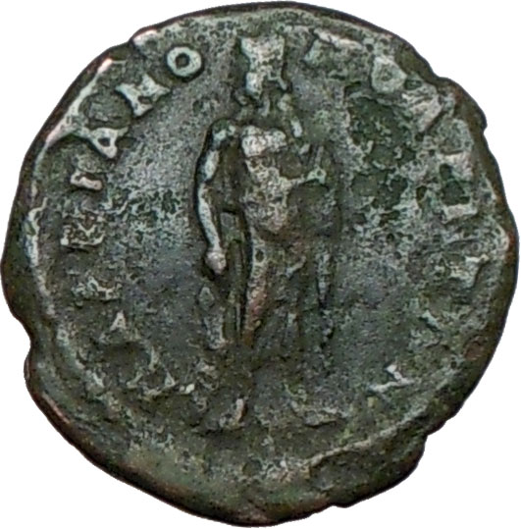

**Diadumenian - Roman Caesar: 218 A.D. (45usd)**Bronze Assarion 17mm (3.25 grams) of Marcianopolis in Moesta Inferior circa 218 A.D.  
 M OΠЄΛΛI  ANTΩNIIN , Bare-headed draped bust right.  
MAPKIANOΠOΛЄITΩN ,  Asclepius standing facing, holding serpent enttwined, medical-  
symbol staff.

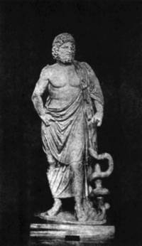**Asclepius** is the god of [medicine](http://en.wikipedia.org/wiki/Medicine) and healing in ancient [Greek religion](http://en.wikipedia.org/wiki/Religion_in_ancient_Greece). Asclepius represents the healing aspect of the medical arts; his daughters are [Hygieia](http://en.wikipedia.org/wiki/Hygieia) ("Health"), [Iaso](http://en.wikipedia.org/wiki/Iaso) ("Medicine"), [Aceso](http://en.wikipedia.org/wiki/Aceso) ("Healing"), [Aglæa/Ægle](http://en.wikipedia.org/wiki/Aglaea) ("Healthy Glow"), and [Panacea](http://en.wikipedia.org/wiki/Panacea) ("Universal Remedy"). The [rod of Asclepius](http://en.wikipedia.org/wiki/Rod_of_Asclepius), a snake-entwined staff, remains a symbol of medicine today, although sometimes the [caduceus](http://en.wikipedia.org/wiki/Caduceus), or staff with two snakes, is mistakenly used instead. He was associated with the Roman/Etruscan god [Vediovis](http://en.wikipedia.org/wiki/Vediovis). He was one of [Apollo](http://en.wikipedia.org/wiki/Apollo)'s servants.

The **rod of Asclepius**, also known as the **asklepian**, is an ancient symbol associated with [astrology](http://en.wikipedia.org/wiki/Astrology), the [Greek](http://en.wikipedia.org/wiki/Greece) [god](http://en.wikipedia.org/wiki/God) [Asclepius](http://en.wikipedia.org/wiki/Asclepius) and with [medicine](http://en.wikipedia.org/wiki/Medicine) and [healing](http://en.wikipedia.org/wiki/Healing). It consists of a [serpent](http://en.wikipedia.org/wiki/Serpent_(symbolism%2529) entwined around a [staff](http://en.wikipedia.org/wiki/Staff_(stick%2529). The name of the symbol derives from its early and widespread association with [Asclepius](http://en.wikipedia.org/wiki/Asclepius), the son of [Apollo](http://en.wikipedia.org/wiki/Apollo), who was a practitioner of medicine in ancient [Greek mythology](http://en.wikipedia.org/wiki/Greek_mythology). His attributes, the snake and the staff, sometimes depicted separately in antiquity, are combined in this symbol. The Rod of Asclepius also represents the constellation [Ophiuchus](http://en.wikipedia.org/wiki/Ophiuchus) (or Ophiuchus Serpentarius), the thirteenth sign of the [sidereal zodiac](http://en.wikipedia.org/wiki/Sidereal_zodiac). [Hippocrates](http://en.wikipedia.org/wiki/Hippocrates) himself was a worshipper of Asclepius.

**Marcianopolis**, or **Marcianople** was an ancient Roman city in [Thracia](http://en.wikipedia.org/wiki/Thracia). It was located at the site of modern day [Devnya](http://en.wikipedia.org/wiki/Devnya), [Bulgaria](http://en.wikipedia.org/wiki/Bulgaria).

The city was so renamed by Emperor [Trajan](http://en.wikipedia.org/wiki/Trajan) after his sister [Ulpia Marciana](http://en.wikipedia.org/wiki/Ulpia_Marciana), and was previously known as Parthenopolis. Romans repulsed a [Gothic](http://en.wikipedia.org/wiki/Goths) attack to this town in [267](http://en.wikipedia.org/wiki/267) (or [268](http://en.wikipedia.org/wiki/268)), during the reign of [Gallienus](http://en.wikipedia.org/wiki/Gallienus). [Diocletian](http://en.wikipedia.org/wiki/Diocletian) made it the capital of the [Moesia Secunda](http://en.wikipedia.org/wiki/Moesia_Secunda) province.

[Valens](http://en.wikipedia.org/wiki/Valens) made it his winter quarters in 368 and succeeding years, Emperor [Justinian I](http://en.wikipedia.org/wiki/Justinian_I) restored and fortified it. In 587, it was sacked by the king of the [Avars](http://en.wikipedia.org/wiki/Eurasian_Avars) but at once retaken by the Romans. The Roman army quartered there in 596 before crossing the Danube to assault the Avars.

Between 893 and 972 it was one of the most important medieval cities in south-eastern Europe.

**Marcus Opellius Antoninus Diadumenianus** or **Diadumenian** (208–218) was the son of the Roman Emperor Macrinus, and served his father briefly as Caesar (May 217–218) and as Augustus (in 218). Diadumenian was born in 14th of September 208 a.C or according to Historia Augusta in 19th of September 208 a.C because he shared the same birthday with the emperor Antoninus Pius. His mother was Empress Nonia Celsa, although her existence remains dubious, because she was only mentioned by the Historia Augusta. He was born Marcus Opellius Diadumenianus, but his name was changed and added Antoninus to solidify connection to the family of Marcus Aurelius as done by Caracalla.  
  
Diadumenian had little time to enjoy his position or to learn anything from its opportunities because the legions of Syria revolted and declared Elagabalus ruler of the Roman Empire. When Macrinus was defeated on June 8, 218, at Antioch, Diadumenian followed his father's death.

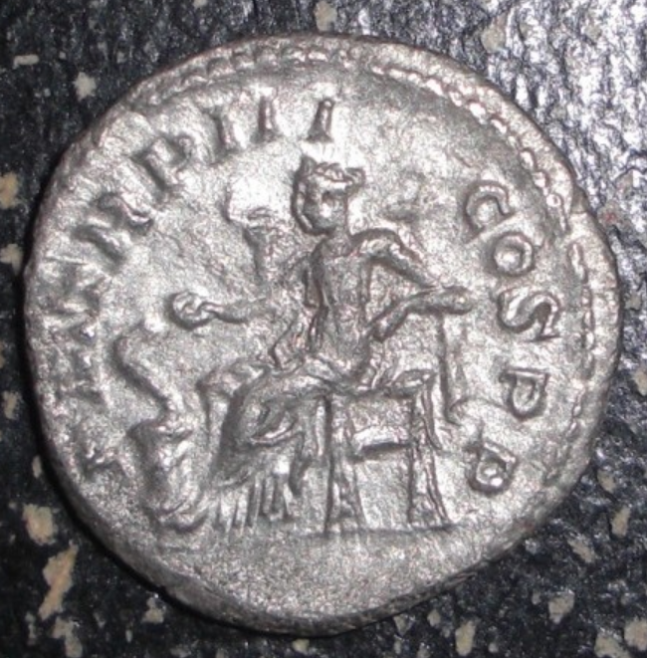 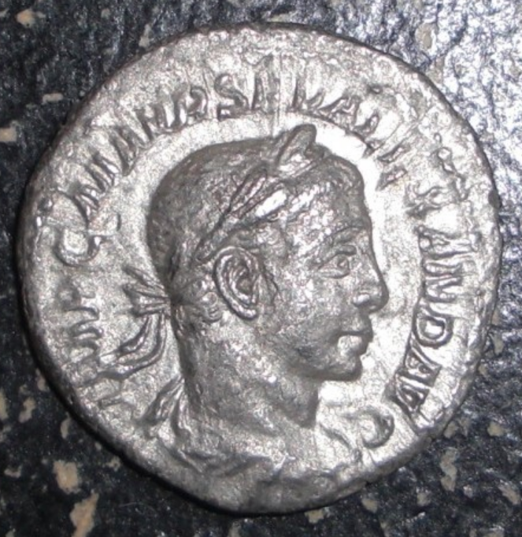

Ancient Roman. Severus Alexander. 222 - 235 AD. Silver Denarius. Rome Mint. Salus seated lt. 18 mm.

58usd

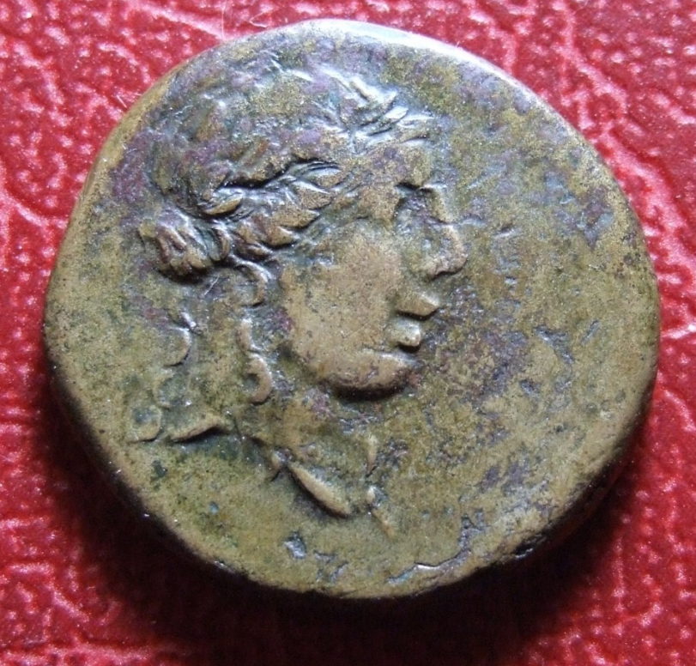

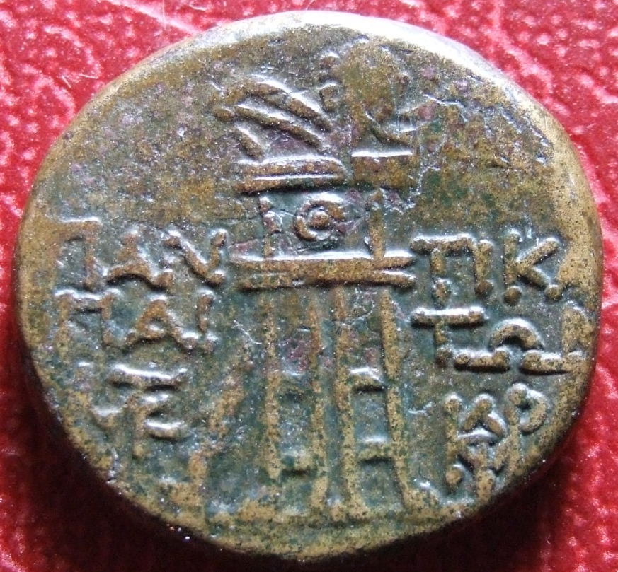

Description

Taurian Chersonesus (USD 60)

Bronze, 100-75. Apollo head with laurel wreath

Rv. PAN-TIK [A] ??/ TWN PAI- Dreifuss, thyrsos is leaning, in the field below r. Monogram. 7.60 g

Av. Excellent. Rv. Very nice

Ref :BAS276

This coin is authentic of the period

Diameter 21mmThickness 3mm Weight 7.6gr

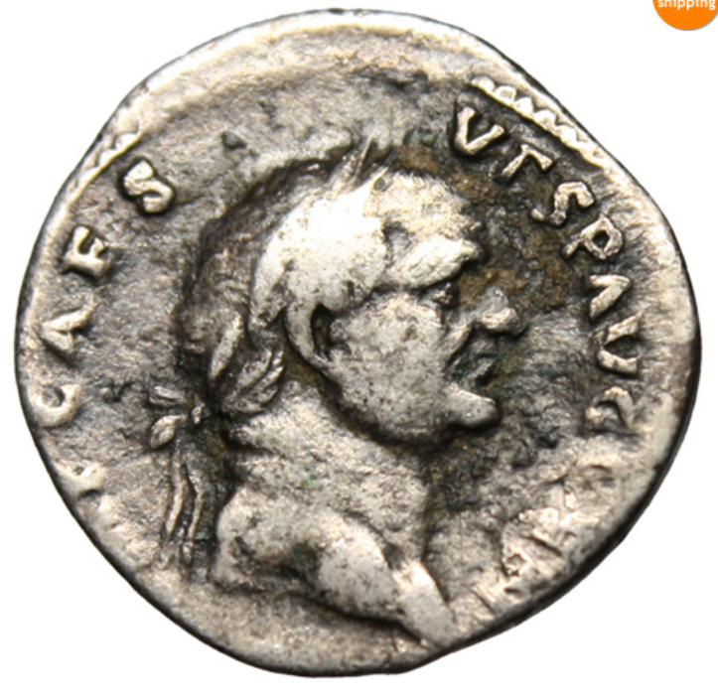 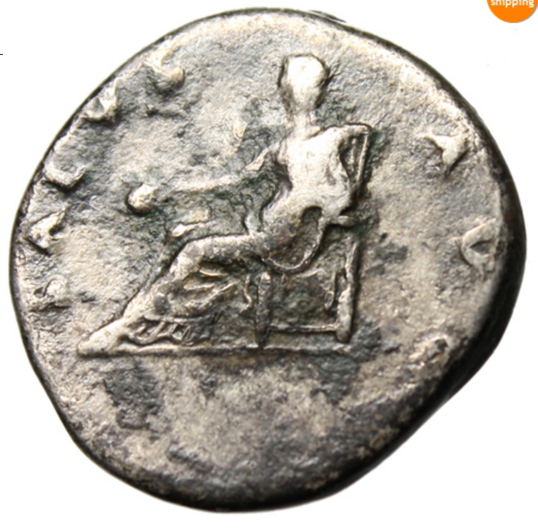

Vespasian AR Denarius (usd60)

Rome Mint 73 AD

Obverse: IMP CAES VESP AVG CEN, laureate head right

Reverse: SALVS AVG, Salus seated left, patera in right

RIC II: 67 Size: 19mm, 3.26g

**Numismatic Notes:** Near Fine. Toned.

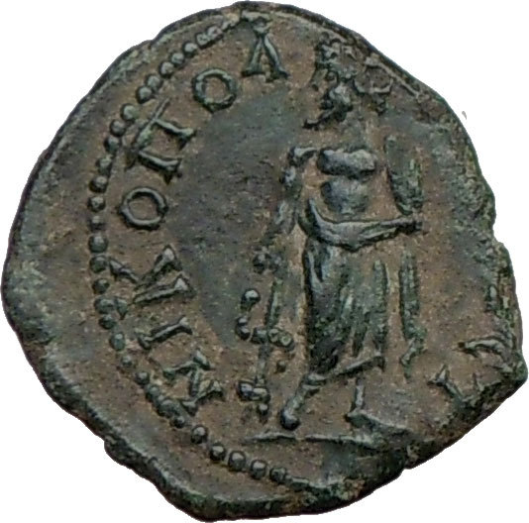 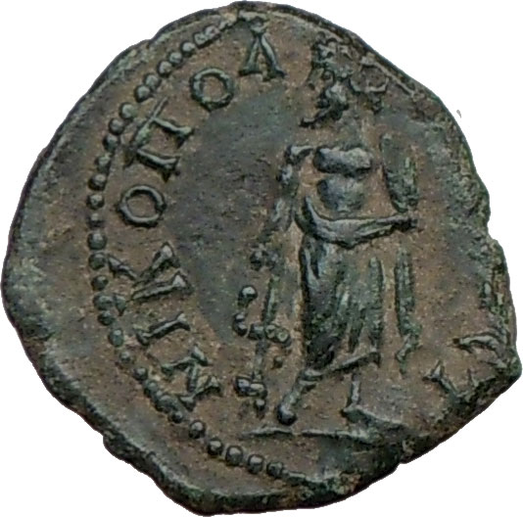

**Caracalla - Roman Emperor: 198-217 A.D. - (usd 150)**Bronze 16mm (2.79 grams) Struck in the Roman Provincial city of Nicopolis ad Istrum in Moesia Inferior   
 AV K M AP ANTΩNINO, Laureate head right.   
NIKOΠOΛIT ΠPOC I, Asclepius standing facing, head left, holding serpent-entwined medical symbol staff.

You are bidding on the exact item pictured, provided with a Certificate of Authenticity and Lifetime Guarantee of Authenticity.

**Asclepius** is the god of [medicine](http://en.wikipedia.org/wiki/Medicine) and healing in ancient [Greek religion](http://en.wikipedia.org/wiki/Religion_in_ancient_Greece). Asclepius represents the healing aspect of the medical arts; his daughters are [Hygieia](http://en.wikipedia.org/wiki/Hygieia) ("Health"), [Iaso](http://en.wikipedia.org/wiki/Iaso) ("Medicine"), [Aceso](http://en.wikipedia.org/wiki/Aceso) ("Healing"), [Aglæa/Ægle](http://en.wikipedia.org/wiki/Aglaea) ("Healthy Glow"), and [Panacea](http://en.wikipedia.org/wiki/Panacea) ("Universal Remedy"). The [rod of Asclepius](http://en.wikipedia.org/wiki/Rod_of_Asclepius), a snake-entwined staff, remains a symbol of medicine today, although sometimes the [caduceus](http://en.wikipedia.org/wiki/Caduceus), or staff with two snakes, is mistakenly used instead. He was associated with the Roman/Etruscan god [Vediovis](http://en.wikipedia.org/wiki/Vediovis). He was one of [Apollo](http://en.wikipedia.org/wiki/Apollo)'s servants.

The **rod of Asclepius**, also known as the **asklepian**, is an ancient symbol associated with [astrology](http://en.wikipedia.org/wiki/Astrology), the [Greek](http://en.wikipedia.org/wiki/Greece) [god](http://en.wikipedia.org/wiki/God) [Asclepius](http://en.wikipedia.org/wiki/Asclepius) and with [medicine](http://en.wikipedia.org/wiki/Medicine) and [healing](http://en.wikipedia.org/wiki/Healing). It consists of a [serpent](http://en.wikipedia.org/wiki/Serpent_(symbolism%2529) entwined around a [staff](http://en.wikipedia.org/wiki/Staff_(stick%2529). The name of the symbol derives from its early and widespread association with [Asclepius](http://en.wikipedia.org/wiki/Asclepius), the son of [Apollo](http://en.wikipedia.org/wiki/Apollo), who was a practitioner of medicine in ancient [Greek mythology](http://en.wikipedia.org/wiki/Greek_mythology). His attributes, the snake and the staff, sometimes depicted separately in antiquity, are combined in this symbol. The Rod of Asclepius also represents the constellation [Ophiuchus](http://en.wikipedia.org/wiki/Ophiuchus) (or Ophiuchus Serpentarius), the thirteenth sign of the [sidereal zodiac](http://en.wikipedia.org/wiki/Sidereal_zodiac). [Hippocrates](http://en.wikipedia.org/wiki/Hippocrates) himself was a worshipper of Asclepius.

**Nicopolis ad Istrum** was a [Roman](http://en.wikipedia.org/wiki/Ancient_Rome) and Early [Byzantine](http://en.wikipedia.org/wiki/Byzantine_Empire) town founded by Emperor [Trajan](http://en.wikipedia.org/wiki/Trajan) around 101–106, at the junction of the Iatrus ([Yantra](http://en.wikipedia.org/wiki/Yantra_River)) and the [Rositsa](http://en.wikipedia.org/wiki/Rositsa) rivers, in memory of his victory over the [Dacians](http://en.wikipedia.org/wiki/Dacia). Its ruins are located at the village of [Nikyup](http://en.wikipedia.org/w/index.php?title=Nikyup&action=edit&redlink=1), 20 km north of [Veliko Tarnovo](http://en.wikipedia.org/wiki/Veliko_Tarnovo) in northern [Bulgaria](http://en.wikipedia.org/wiki/Bulgaria). The town reached its apogee during the reigns of Trajan, [Hadrian](http://en.wikipedia.org/wiki/Hadrian), the [Antonines](http://en.wikipedia.org/wiki/Antonines) and the [Severan dynasty](http://en.wikipedia.org/wiki/Severan_dynasty).

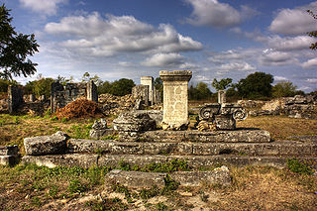

The classical town was planned according to the orthogonal system. The network of streets, the forum surrounded by an Ionic colonnade and many buildings, a two-nave room later turned into a basilica and other public buildings have been uncovered. The rich architectures and sculptures show a similarity with those of the ancient towns in Asia Minor. Nicopolis ad Istrum had issued coins, bearing images of its own public buildings.

In [447 AD](http://en.wikipedia.org/wiki/447_AD), the town was destroyed by [Attila's](http://en.wikipedia.org/wiki/Attila) [Huns](http://en.wikipedia.org/wiki/Huns). Perhaps it was already abandoned before the early 400s. In the 6th century, it was rebuilt as a powerful fortress enclosing little more than military buildings and churches, following a very common trend for the cities of that century in the Danube area.The largest area of the extensive ruins (21.55 hectares) of the classical Nicopolis was not reoccupied since the fort covered only one fourth of it (5.75 hectares), in the southeastern corner. The town became an episcopal centre during the early Byzantine period. It was finally destroyed by the Avar invasions at the end of the 6th century. A Bulgarian medieval settlement arose upon its ruins later (10th-14th century).

Nicopolis ad Istrum can be said to have been the birthplace of [Germanic](http://en.wikipedia.org/wiki/Germanic_languages) literary tradition. In the 4th century, the [Gothic](http://en.wikipedia.org/wiki/Goths) bishop, missionary and translator [Ulfilas](http://en.wikipedia.org/wiki/Ulfilas) (Wulfila) obtained permission from Emperor [Constantius II](http://en.wikipedia.org/wiki/Constantius_II) to immigrate with his flock of converts to Moesia and settle near Nicopolis ad Istrum in 347-8. There, he invented the [Gothic alphabet](http://en.wikipedia.org/wiki/Gothic_alphabet) and translated the [Bible](http://en.wikipedia.org/wiki/Bible) from [Greek](http://en.wikipedia.org/wiki/Greek_language) to [Gothic](http://en.wikipedia.org/wiki/Gothic_language).

**Caracalla** ([April 4](http://en.wikipedia.org/wiki/April_4), [188](http://en.wikipedia.org/wiki/188) – [April 8](http://en.wikipedia.org/wiki/April_8), [217](http://en.wikipedia.org/wiki/217). Caracallus ), born **Lucius Septimius Bassianus** and later called **Marcus** 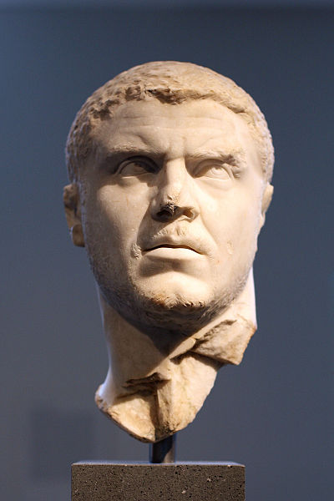**Aurelius Antoninus** and **Marcus Aurelius Severus Antoninus**, was the eldest son of [Septimius Severus](http://en.wikipedia.org/wiki/Septimius_Severus) and [Roman Emperor](http://en.wikipedia.org/wiki/Roman_Emperor) from 211 to 217.[[1]](http://en.wikipedia.org/wiki/Caracalla" \l "cite_note-0) He was one of the most nefarious of Roman emperors.[[2]](http://en.wikipedia.org/wiki/Caracalla" \l "cite_note-1)[[3]](http://en.wikipedia.org/wiki/Caracalla" \l "cite_note-2) Caracalla's reign was notable for:

* the [*Constitutio Antoniniana*](http://en.wikipedia.org/wiki/Constitutio_Antoniniana), granting [Roman citizenship](http://en.wikipedia.org/wiki/Roman_citizenship) to freemen throughout the [Roman Empire](http://en.wikipedia.org/wiki/Roman_Empire), according to [Cassius Dio](http://en.wikipedia.org/wiki/Cassius_Dio) in order to increase taxation;
* debasing the silver content in Roman coinage by 25 percent in order to pay the legions; and
* the construction of a large [thermae](http://en.wikipedia.org/wiki/Thermae) outside Rome, the remains of which, known as the [Baths of Caracalla](http://en.wikipedia.org/wiki/Baths_of_Caracalla), can still be seen today

"Caracalla was the common enemy of all mankind," wrote [Edward Gibbon](http://en.wikipedia.org/wiki/Edward_Gibbon).[[4]](http://en.wikipedia.org/wiki/Caracalla" \l "cite_note-Gibbon-3) He spent his reign traveling from province to province so that each could experience his "rapine and cruelty."[[4]](http://en.wikipedia.org/wiki/Caracalla" \l "cite_note-Gibbon-3)

## Rise to power

Caracalla, of mixed [Punic](http://en.wikipedia.org/wiki/Punic)/[Berber](http://en.wikipedia.org/wiki/Berber_people)[[5]](http://en.wikipedia.org/wiki/Caracalla" \l "cite_note-4)[[6]](http://en.wikipedia.org/wiki/Caracalla" \l "cite_note-5) and [Syrian](http://en.wikipedia.org/wiki/Syria) [Arab](http://en.wikipedia.org/wiki/Arabs) descent, [[7]](http://en.wikipedia.org/wiki/Caracalla" \l "cite_note-6)[[8]](http://en.wikipedia.org/wiki/Caracalla" \l "cite_note-7)[[9]](http://en.wikipedia.org/wiki/Caracalla" \l "cite_note-8) was born Lucius Septimius Bassianus in [Lugdunum](http://en.wikipedia.org/wiki/Lugdunum), [Gaul](http://en.wikipedia.org/wiki/Gaul) (now [Lyon](http://en.wikipedia.org/wiki/Lyon), [France](http://en.wikipedia.org/wiki/France)), the son of the later Emperor Septimius Severus and [Julia Domna](http://en.wikipedia.org/wiki/Julia_Domna). At the age of seven, his name was changed to Marcus Aurelius Septimius Bassianus Antoninus to solidify connection to the family of [Marcus Aurelius](http://en.wikipedia.org/wiki/Marcus_Aurelius). He was later given the [nickname](http://en.wikipedia.org/wiki/Caracalla" \l "His_nickname) *Caracalla*, which referred to the Gallic hooded tunic he habitually wore and which he made fashionable.

His father, who had taken the imperial throne in 193, died in 211 while touring the northern marches at [Eboracum](http://en.wikipedia.org/wiki/Eboracum) ([York](http://en.wikipedia.org/wiki/York)), and Caracalla was proclaimed co-emperor with his brother [Publius Septimius Antoninius Geta](http://en.wikipedia.org/wiki/Publius_Septimius_Geta). However since both of them wanted to be the sole ruler, tensions between the brothers were evident in the few months they ruled the empire together (they even considered dividing the empire in two, but were persuaded not to do so by their mother). In December 211, Caracalla had Geta, the family of his former father-in-law [Gaius Fulvius Plautianus](http://en.wikipedia.org/wiki/Gaius_Fulvius_Plautianus), his wife [Fulvia Plautilla](http://en.wikipedia.org/wiki/Fulvia_Plautilla) (also his paternal second cousin), and her brother assassinated. He persecuted Geta's supporters and ordered a [*damnatio memoriae*](http://en.wikipedia.org/wiki/Damnatio_memoriae) by the Senate against his brother.

## Reign

In 213 Caracalla went north to the German frontier to deal with the [Alamanni](http://en.wikipedia.org/wiki/Alamanni) who were causing trouble in the [Agri Decumates](http://en.wikipedia.org/wiki/Agri_Decumates). The emperor managed to win the sympathy of the soldiers with generous pay rises and popular gestures, like marching on foot among the ordinary soldiers, eating the same food, and even grinding his own flour with them.

Caracalla defeated the Alamanni in a battle near the river [Main](http://en.wikipedia.org/wiki/Main), but failed to win a decisive victory over them. After a peace agreement was brokered, the senate conferred upon him the title "Germanicus Maximus". In the next year the emperor traveled to the East.

When the inhabitants of [Alexandria](http://en.wikipedia.org/wiki/Alexandria,_Egypt) heard Caracalla's claims that he had killed Geta in self-defense, they produced a satire mocking this claim, as well as Caracalla's other pretensions. Caracalla responded to this insult savagely in 215 by slaughtering the deputation of leading citizens who had unsuspectingly assembled before the city to greet his arrival, and then unleashed his troops for several days of looting and plunder in Alexandria. According to historian Cassius Dio, over 20,000 people were killed.

During his reign as emperor, Caracalla raised the annual pay of an average legionary to 675 [*denarii*](http://en.wikipedia.org/wiki/Denarii) and lavished many benefits on the army which he both feared and admired, as instructed by his father Septimius Severus who had told him to always mind the soldiers and ignore everyone else.[[10]](http://en.wikipedia.org/wiki/Caracalla" \l "cite_note-9) His official portraiture marked a break with the detached images of the philosopher-emperors who preceded him: his close-cropped haircut is that of a soldier, his pugnacious scowl a realistic and threatening presence. The rugged soldier-emperor iconic type was adopted by several of the following emperors who depended on the support of the legions, like [Trebonianus Gallus](http://en.wikipedia.org/wiki/Trebonianus_Gallus).[[11]](http://en.wikipedia.org/wiki/Caracalla" \l "cite_note-10)

Seeking to secure his own legacy, Caracalla also commissioned one of Rome's last major architectural achievements, the [Baths of Caracalla](http://en.wikipedia.org/wiki/Baths_of_Caracalla), the largest public bath ever built in ancient Rome. The main room of the baths was larger than [St. Peter's Basilica](http://en.wikipedia.org/wiki/St._Peter's_Basilica), and could easily accommodate over 2,000 Roman citizens at one time. The bath house opened in 216, complete with private rooms and outdoor tracks. Internally it was decorated with golden trim and mosaics.

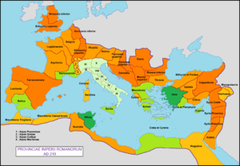

The Roman Empire and its provinces in 210 AD

## Fall

While travelling from [Edessa](http://en.wikipedia.org/wiki/Edessa,_Mesopotamia) to begin a war with [Parthia](http://en.wikipedia.org/wiki/Parthia), he was assassinated while urinating at a roadside near [Harran](http://en.wikipedia.org/wiki/Harran) on [April 8](http://en.wikipedia.org/wiki/April_8), [217](http://en.wikipedia.org/wiki/217) by Julius Martialis, an officer in the imperial bodyguard. [Herodian](http://en.wikipedia.org/wiki/Herodian) says that Martialis' brother had been executed a few days earlier by Caracalla on an unproven charge; Cassius Dio, on the other hand, says that Martialis was resentful at not being promoted to the rank of centurion. The escort of the emperor gave him privacy to relieve himself, and Martialis ran forward and killed Caracalla with a single sword stroke. He immediately fled on horseback, but was killed by a bodyguard archer.[[*citation needed*](http://en.wikipedia.org/wiki/Wikipedia:Citation_needed)]

Caracalla was succeeded by the Praetorian Prefect of the Guard, [Macrinus](http://en.wikipedia.org/wiki/Macrinus), who almost certainly was part of the conspiracy against the emperor.[[*citation needed*](http://en.wikipedia.org/wiki/Wikipedia:Citation_needed)]

## His nickname

According to [Aurelius Victor](http://en.wikipedia.org/wiki/Aurelius_Victor) in his *Epitome de Caesaribus*, the [cognomen](http://en.wikipedia.org/wiki/Cognomen) "Caracalla" refers to a Gallic [cloak](http://en.wikipedia.org/wiki/Cloak) that Caracalla adopted as a personal fashion, which spread to his army and his court.[[12]](http://en.wikipedia.org/wiki/Caracalla" \l "cite_note-11) Cassius Dio[[13]](http://en.wikipedia.org/wiki/Caracalla" \l "cite_note-12) and the [*Historia Augusta*](http://en.wikipedia.org/wiki/Augustan_History)[[14]](http://en.wikipedia.org/wiki/Caracalla" \l "cite_note-13) agree that his nickname derived from his cloak, but do not mention its country of origin.

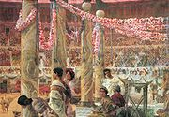

Caracalla and Geta by [Lawrence Alma-Tadema](http://en.wikipedia.org/wiki/Lawrence_Alma-Tadema). 1907.

## Legendary king of Britain

[Geoffrey of Monmouth](http://en.wikipedia.org/wiki/Geoffrey_of_Monmouth)'s legendary [*History of the Kings of Britain*](http://en.wikipedia.org/wiki/Historia_Regum_Britanniae) makes Caracalla a king of Britain, referring to him by his actual name "Bassianus", rather than the nickname Caracalla. After Severus's death, the Romans wanted to make Geta king of Britain, but the Britons preferred Bassianus because he had a British mother. The two brothers fought a battle in which Geta was killed, and Bassianus succeeded to the throne. He ruled until he was betrayed by his [Pictish](http://en.wikipedia.org/wiki/Picts) allies and overthrown by [Carausius](http://en.wikipedia.org/wiki/Carausius), who, according to Geoffrey, was a Briton, rather than the [Menapian](http://en.wikipedia.org/wiki/Menapii) Gaul that he actually was.[[15]](http://en.wikipedia.org/wiki/Caracalla" \l "cite_note-14)

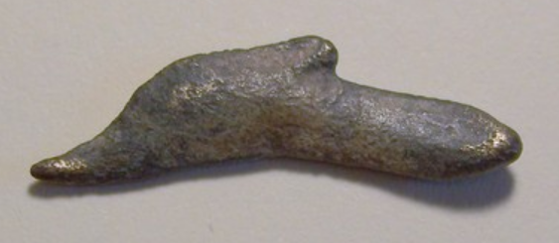

OLBIA 27,6 mm in lenght , weight 1,4 grams . (22 usd)

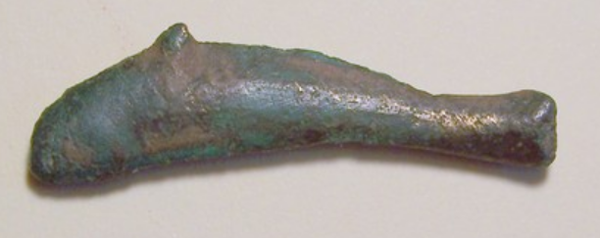

Olbia (28 usd)

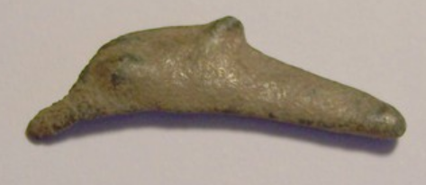

Olbia (15 usd) 25,3 mm in lenght , weight 1,2 grams .

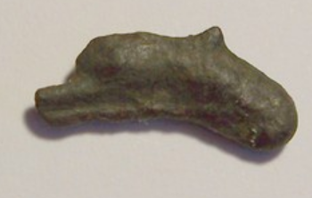

Olbia 25,3 mm in lenght , weight 1,2 grams . (17usd)

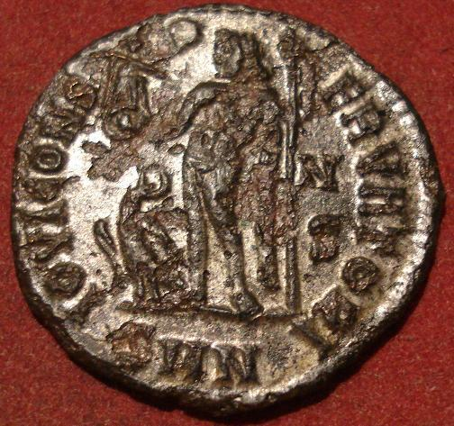 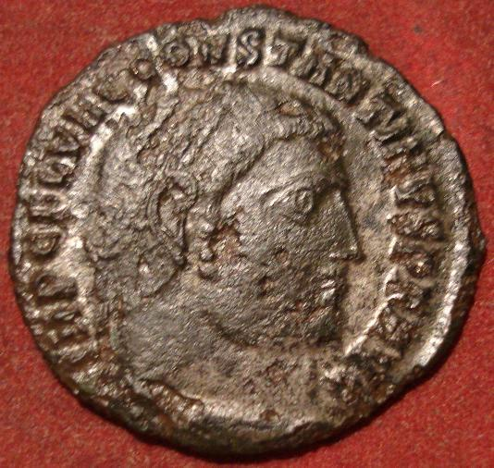

**CONSTANTINE I "The Great" Roman Bronze Silvered Follis JUPITER(b1) (13 usd)  
Diameter: 21,5 mm  
Weight: 2,9 g**

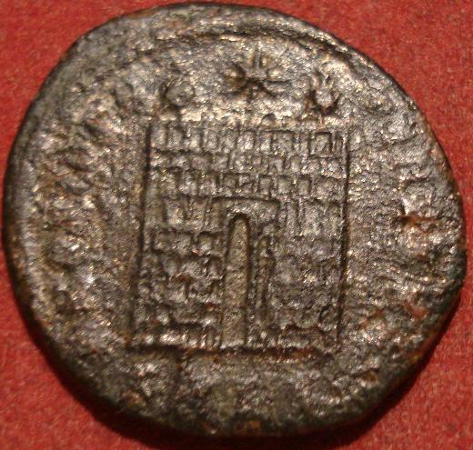 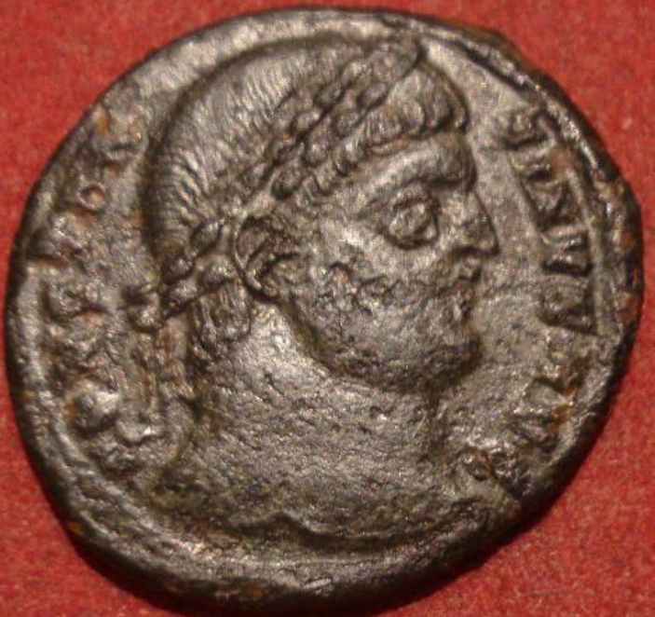

**CONSTANTINE I Campgate Roman Bronze Coin(b28) 13usd  
  
Diameter: 18,5 mm  
Weight: 2,7 g**

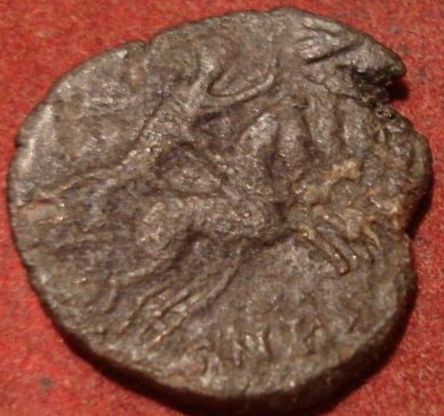 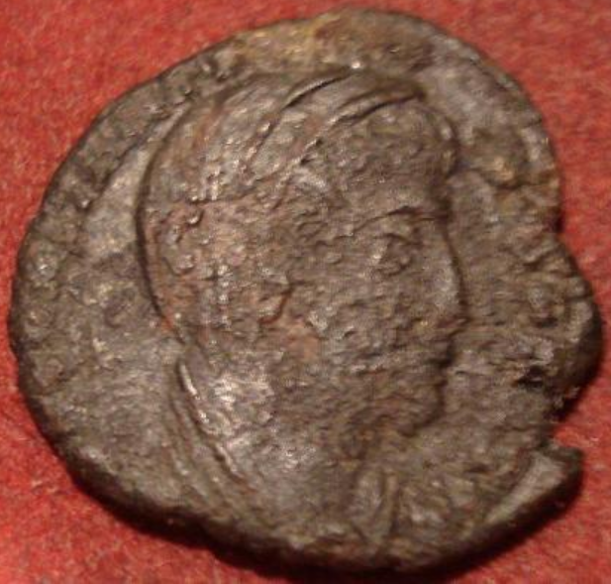 **CONSTANTINE I Posthumous Roman Bronze Coin Quadriga(c74) 13usd  
  
Diameter: 14,5 mm  
Weight: 1,5 g**

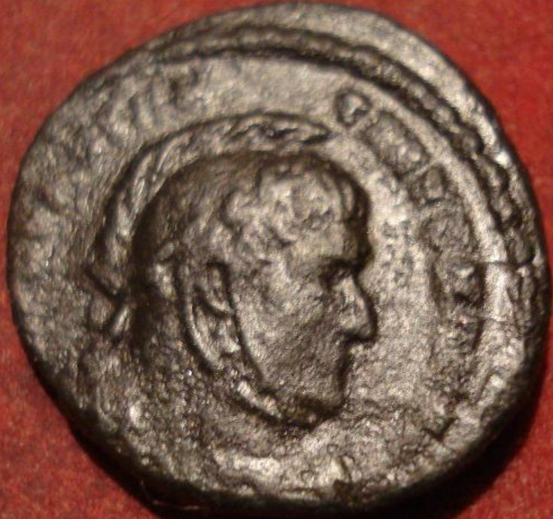 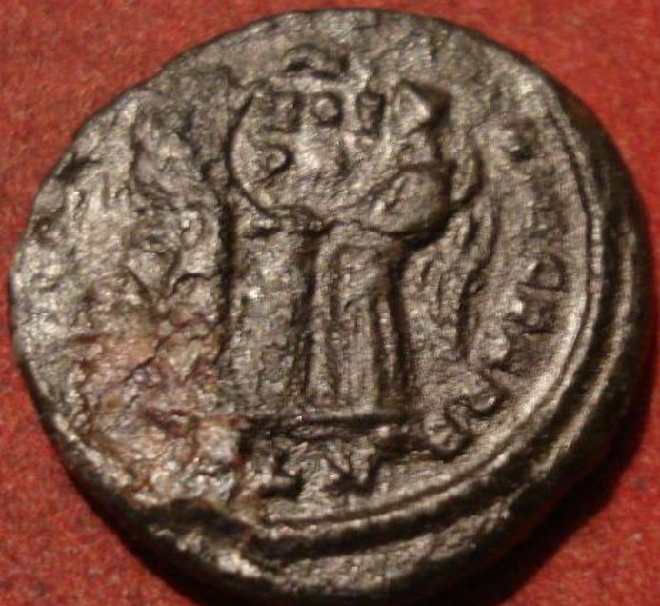 **CONSTANTINE I "The Great" Roman Bronze Coin "Two Victories"(c63)  
  
Diameter: 16,5 mm  
Weight: 3,4 g** 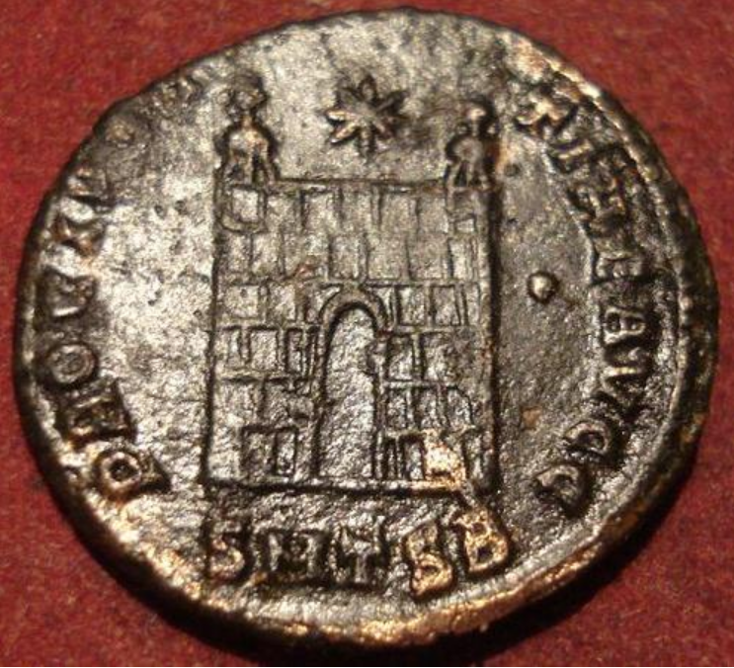 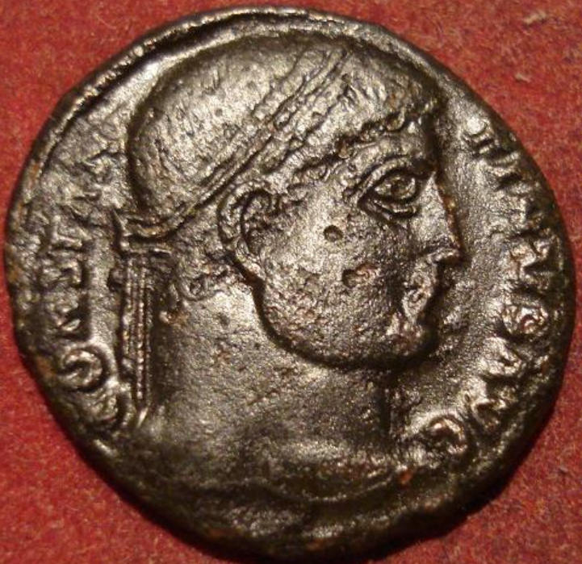 **CONSTANTINE I Campgate Roman Bronze Coin(d6) 15usd  
  
Diameter: 18,5 mm  
Weight: 3,0 g**

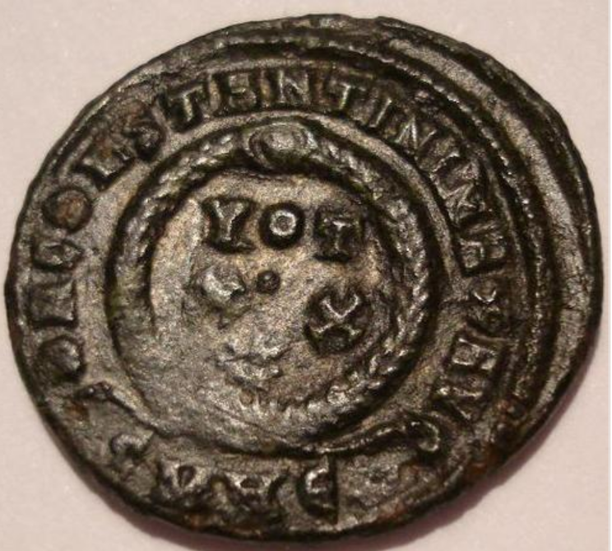 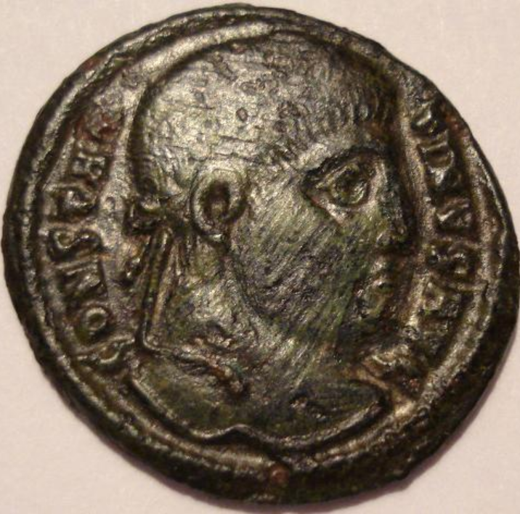 **CONSTANTINE I Roman Bronze Coin "Votive"(d15) 23usd  
  
Diameter: 18,5 mm  
Weight: 2,8 g**

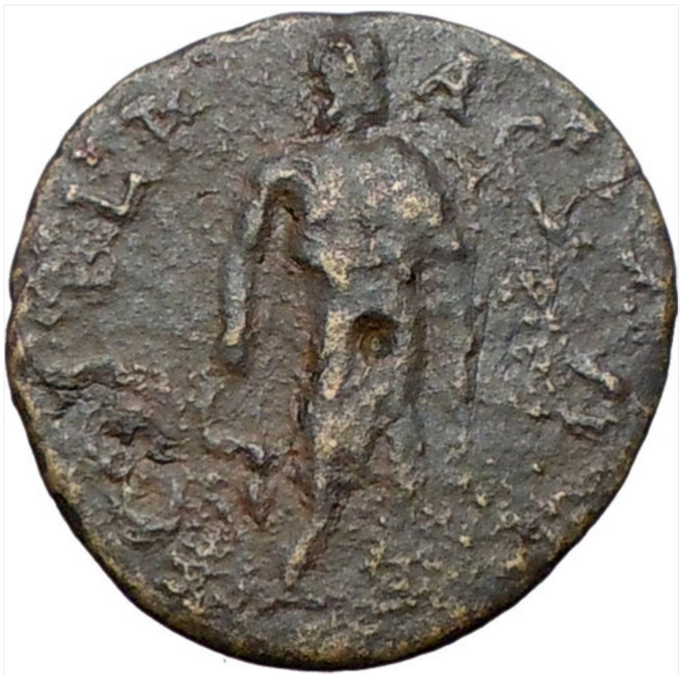 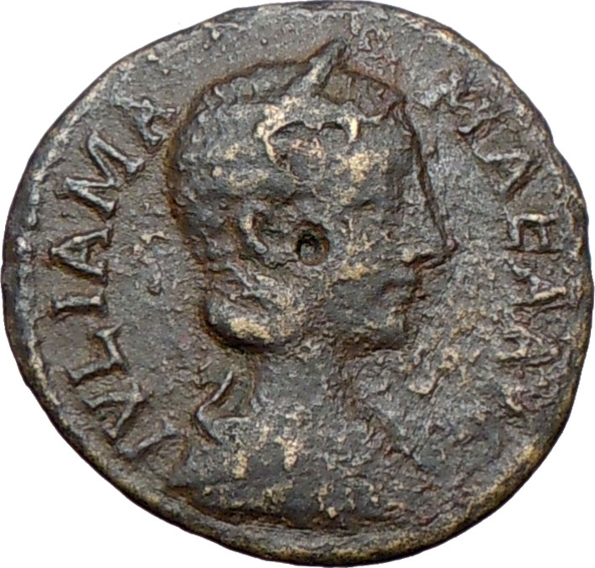 **Julia Mamaea - Roman Empress wife of Emperor Severus Alexander 222-235 A.D. - 125 usd** Bronze 24mm (5.69 grams) Struck in the city of Deultum in Thrace.   
IVLIA MAMAEA AVG, Diademed, draped bust right   
COL F L PAC DEVLT, Asclepius, the God of Medicine, standing  
left and holdinh serpent-entwined medical symbol staff.

You are bidding on the exact item pictured, provided with a Certificate of Authenticity and Lifetime Guarantee of Authenticity.

**Asclepius** is the god of [medicine](http://en.wikipedia.org/wiki/Medicine) and healing in ancient [Greek religion](http://en.wikipedia.org/wiki/Religion_in_ancient_Greece). Asclepius represents the healing aspect of the medical arts; his daughters are [Hygieia](http://en.wikipedia.org/wiki/Hygieia) ("Health"), [Iaso](http://en.wikipedia.org/wiki/Iaso) ("Medicine"), [Aceso](http://en.wikipedia.org/wiki/Aceso) ("Healing"), [Aglæa/Ægle](http://en.wikipedia.org/wiki/Aglaea) ("Healthy Glow"), and [Panacea](http://en.wikipedia.org/wiki/Panacea) ("Universal Remedy"). The [rod of Asclepius](http://en.wikipedia.org/wiki/Rod_of_Asclepius), a snake-entwined staff, remains a symbol of medicine today, although sometimes the [caduceus](http://en.wikipedia.org/wiki/Caduceus), or staff with two snakes, is mistakenly used instead. He was associated with the Roman/Etruscan god [Vediovis](http://en.wikipedia.org/wiki/Vediovis). He was one of [Apollo](http://en.wikipedia.org/wiki/Apollo)'s servants.

The **rod of Asclepius**, also known as the **asklepian**, is an ancient symbol associated with [astrology](http://en.wikipedia.org/wiki/Astrology), the [Greek](http://en.wikipedia.org/wiki/Greece) [god](http://en.wikipedia.org/wiki/God) [Asclepius](http://en.wikipedia.org/wiki/Asclepius) and with [medicine](http://en.wikipedia.org/wiki/Medicine) and [healing](http://en.wikipedia.org/wiki/Healing). It consists of a [serpent](http://en.wikipedia.org/wiki/Serpent_(symbolism%2529) entwined around a [staff](http://en.wikipedia.org/wiki/Staff_(stick%2529). The name of the symbol derives from its early and widespread association with [Asclepius](http://en.wikipedia.org/wiki/Asclepius), the son of [Apollo](http://en.wikipedia.org/wiki/Apollo), who was a practitioner of medicine in ancient [Greek mythology](http://en.wikipedia.org/wiki/Greek_mythology). His attributes, the snake and the staff, sometimes depicted separately in antiquity, are combined in this symbol. The Rod of Asclepius also represents the constellation [Ophiuchus](http://en.wikipedia.org/wiki/Ophiuchus) (or Ophiuchus Serpentarius), the thirteenth sign of the [sidereal zodiac](http://en.wikipedia.org/wiki/Sidereal_zodiac). [Hippocrates](http://en.wikipedia.org/wiki/Hippocrates) himself was a worshipper of Asclepius.

**Julia Avita Mamaea** (14 or 29 August after 180–235) was the second daughter of [Julia Maesa](http://en.wikipedia.org/wiki/Julia_Maesa), a powerful [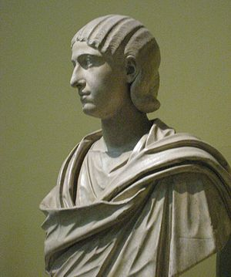Roman woman](http://en.wikipedia.org/wiki/Women_in_Rome) of [Syrian](http://en.wikipedia.org/wiki/Syria) [Arab](http://en.wikipedia.org/wiki/Arab) origin and Syrian noble [Julius Avitus](http://en.wikipedia.org/wiki/Julius_Avitus). She was a niece of empress [Julia Domna](http://en.wikipedia.org/wiki/Julia_Domna) and [emperor](http://en.wikipedia.org/wiki/Roman_Emperor) [Septimius Severus](http://en.wikipedia.org/wiki/Septimius_Severus) and sister of [Julia Soaemias](http://en.wikipedia.org/wiki/Julia_Soaemias). She was born and raised in [Emesa](http://en.wikipedia.org/wiki/Emesa) (modern [Homs](http://en.wikipedia.org/wiki/Homs), [Syria](http://en.wikipedia.org/wiki/Syria)).

Julia's first husband was a former consul (whose name is unknown) who died. Julia married as her second husband Syrian [Promagistrate](http://en.wikipedia.org/wiki/Promagistrate) [Marcus Julius Gessius Marcianus](http://en.wikipedia.org/wiki/Marcus_Julius_Gessius_Marcianus). Julia bore Marcianus two children, a daughter called Theoclia (little is known of her) and a son, Marcus Julius Gessius Bassianus Alexianus, later emperor [Alexander Severus](http://en.wikipedia.org/wiki/Alexander_Severus). Unlike her sister, Julia Mamaea was reported to be a virtuous woman, never involved in scandals.

As a member of the Imperial Roman family, she watched closely the death of her cousin [Caracalla](http://en.wikipedia.org/wiki/Caracalla) and the ascent to power of her nephew [Elagabalus](http://en.wikipedia.org/wiki/Elagabalus), the oldest grandson of Julia Maesa and her choice to the throne. Eventually Elagabalus and his mother Julia Soaemias proved incompetent rulers and favour fell on Alexander, Julia's son. He became emperor in 222, following Elagabalus' murder by the [Praetorian Guard](http://en.wikipedia.org/wiki/Praetorian_Guard). Julia and her mother became regents in the name of Alexander, then 14 years old. Upon adulthood, Alexander confirmed his esteem for his mother and named her *consors imperii* (imperial consort). It was in this condition that she accompanied her son in his campaigns: a custom started with [Julia Domna](http://en.wikipedia.org/wiki/Julia_Domna). Thus she travelled to the East, for the campaign against [Parthia](http://en.wikipedia.org/wiki/Parthia) and to the Germania provinces. Julia Mamaea was with Alexander in Moguntiacum (modern [Mainz](http://en.wikipedia.org/wiki/Mainz)), capital of [Germania Superior](http://en.wikipedia.org/wiki/Germania_Superior), when he was assassinated by his troops. She suffered the same fate.

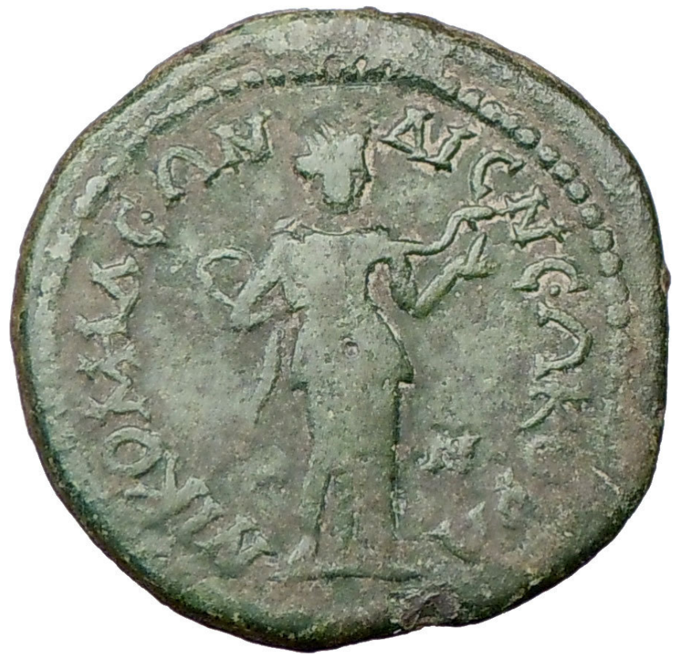 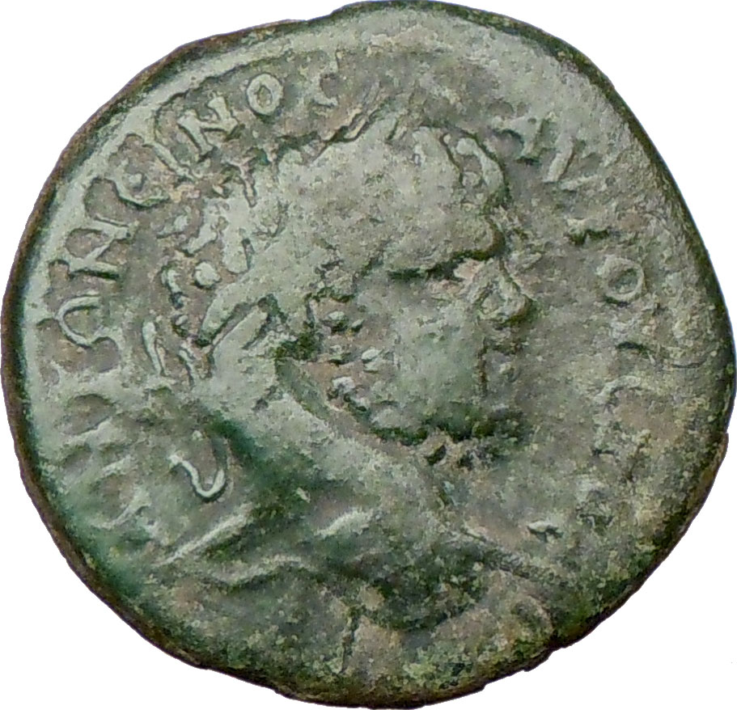

**Caracalla - Roman Emperor: 198-217 A.D. -** US $135.00 (54usd)  
Bronze 30mm (14.74 grams) of Nicomedia in Bithynia circa 211-217 A.D.  
 ANTΩNЄINOC AVΓOVCTOC, laureate head right.  
NIKOMHΔЄΩN ΔIC NЄΩKOPΩN, Hygeia standing right holding serpent.

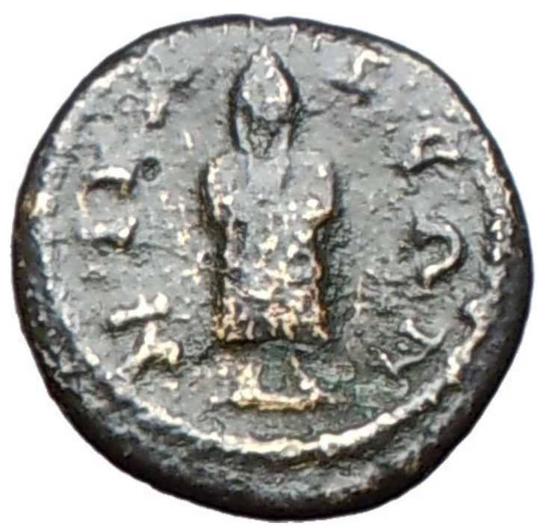 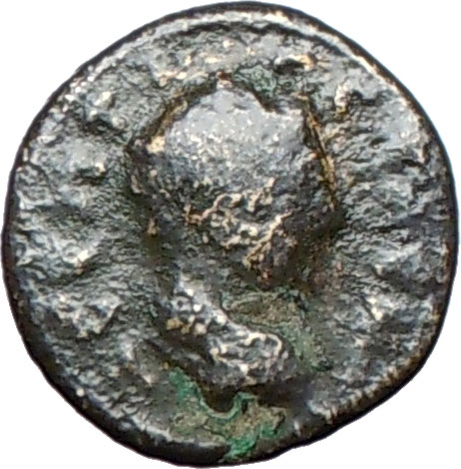

**Geta - Roman Caesar: 198-209 - Emperor: 209-211 A.D. - (45usd)**Bronze 15mm (2.62 grams) Struck at Nicaea in Bythinia circa 198-211 A.D.   
Λ CЄΠT ΓETAC KA, bare-head right.   
NIKAIЄΩN, Telesphorus standing facing.

You are bidding on the exact item pictured, provided with a Certificate of Authenticity and Lifetime Guarantee of Authenticity.

In [Greek mythology](http://en.wikipedia.org/wiki/Greek_mythology), **Telesphorus** (or **Telesphoros**; Τελεσφόρος) was a son of [Asclepius](http://en.wikipedia.org/wiki/Asclepius). He frequently accompanied his sister, [Hygieia](http://en.wikipedia.org/wiki/Hygieia). He was a [dwarf](http://en.wikipedia.org/wiki/Cabeiri) whose head was always covered with a [hood](http://en.wikipedia.org/wiki/Cowl) or [cap](http://en.wikipedia.org/wiki/Phrygian_cap). He symbolized recovery from illness, as his name means "the accomplisher" or "bringer of completion" i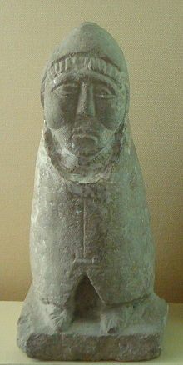n Greek. Representations of him are found mainly in [Anatolia](http://en.wikipedia.org/wiki/Anatolia) and along the [Danube](http://en.wikipedia.org/wiki/Danube).

Telesphorus is assumed to have been a [Celtic god](http://en.wikipedia.org/wiki/Celtic_god) in origin, who was taken to Anatolia by the [Galatians](http://en.wikipedia.org/wiki/Galatia) in the 3rd century BC, where he would have become associated with the Greek god of medicine, Asclepius, perhaps in [Pergamon](http://en.wikipedia.org/wiki/Pergamon), an Asclepian cult center. and spread again to the West due to the rise of the [Roman Empire](http://en.wikipedia.org/wiki/Roman_Empire), in particular during the 2nd century AD, from the reign of [Hadrian](http://en.wikipedia.org/wiki/Hadrian), after [Epidaurus](http://en.wikipedia.org/wiki/Epidaurus), the main center of the cult of Asclepius, had adopted him.

İznik (which derives from the former Greek name Νίκαια, Nicaea) is a city in Turkey which is known primarily as the site of the First and Second Councils of Nicaea, the first and seventh Ecumenical councils in the early history of the Christian church, the Nicene Creed, and as the capital city of the Empire of Nicaea. It served as the interim capital city of the Byzantine Empire between 1204 and 1261, following the Fourth Crusade in 1204, until the recapture of Constantinople by the Byzantines in 1261.  
The city lies in a fertile basin at the eastern end of Lake İznik, bounded by ranges of hills to the north and south. It is situated with its west wall rising from the lake itself, providing both protection from siege from that direction, as well as a source of supplies which would be difficult to cut off. The lake is large enough that it cannot be blockaded from the land easily, and the city was large enough to make any attempt to reach the harbour from shore-based siege weapons very difficult.  
The city is surrounded on all sides by 5 km (3 mi) of walls about 10 m (33 ft) high. These are in turn surrounded by a double ditch on the land portions, and also include over 100 towers in various locations. Large gates on the three landbound sides of the walls provide the only entrance to the city.  
Today the walls are pierced in many places for roads, but much of the early work survives and as a result it is a major tourist destination. The town has a population of about 15,000.

**Publius Septimius Geta** ([March 7](http://en.wikipedia.org/wiki/March_7), [189](http://en.wikipedia.org/wiki/189)–[December 26](http://en.wikipedia.org/wiki/December_26), [211](http://en.wikipedia.org/wiki/211)), was a [Roman Emperor](http://en.wikipedia.org/wiki/Roman_Emperor) co-ruling with his father [Septimius Severus](http://en.wikipedia.org/wiki/Septimius_Severus) and his older brother [Caracalla](http://en.wikipedia.org/wiki/Caracalla) from 209 to his death.

## Early life

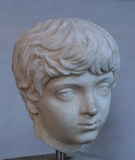

Head of young Geta at [Glyptothek](http://en.wikipedia.org/wiki/Glyptothek), [Munich](http://en.wikipedia.org/wiki/Munich)

Geta was the younger son of Septimius Severus by his second wife [Julia Domna](http://en.wikipedia.org/wiki/Julia_Domna). Geta was born in [Rome](http://en.wikipedia.org/wiki/Rome), at a time when his father was only a provincial governor at the service of emperor [Commodus](http://en.wikipedia.org/wiki/Commodus).

Geta was always in a place secondary to his older brother Lucius, the heir known as Caracalla. Perhaps due to this, the relations between the two were difficult from their early years. Conflicts were constant and often required the mediation of their mother. To appease his youngest son, Septimius Severus gave Geta the title of *Augustus* in 209. During the campaign against the Britons of the early 3rd century, the imperial propaganda publicized a happy family that shared the responsibilities of rule. Caracalla was his father's second in command, Julia Domna the trusted counsellor and Geta had administrative and bureaucratic duties. Truth was that the rivalry and antipathy between the brothers was far from being improved.

## Joint Emperor

When Septimius Severus died in [Eboracum](http://en.wikipedia.org/wiki/York) in the beginning of 211, Caracalla and Geta were proclaimed joint emperors and returned to Rome.

Regardless, the shared throne was not a success: the brothers argued about every decision, from law to political appointments. Later sources speculate about the desire of the two of splitting the empire in two halves. By the end of the year, the situation was unbearable. Caracalla tried to murder Geta during the festival of [Saturnalia](http://en.wikipedia.org/wiki/Saturnalia) without success. Later in December he arranged a meeting with his brother in his mother's apartments, and had him murdered in her arms by [centurions](http://en.wikipedia.org/wiki/Centurion).

Following Geta's assassination, Caracalla [damned his memoryy](http://en.wikipedia.org/wiki/Damnatio_memoriae) and ordered his name to be removed from all inscriptions. The now sole emperor also took the opportunity to get rid of his political enemies, on the grounds of conspiracy with the deceased. [Cassius Dio](http://en.wikipedia.org/wiki/Cassius_Dio) [[1]](http://en.wikipedia.org/wiki/Publius_Septimius_Geta" \l "cite_note-0) stated that around 20,000 persons of both sexes were killed and/or proscribed during this time.

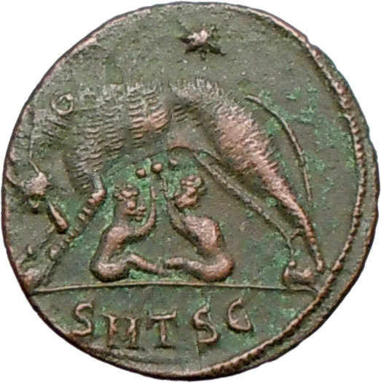 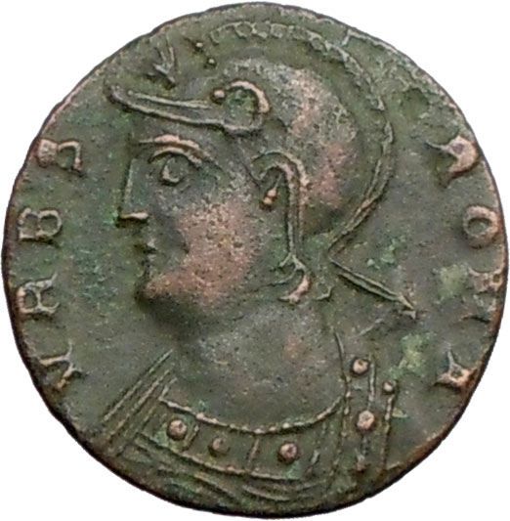

**Constantine I 'The Great'- Roman Emperor: 307-337 A.D. - 175USD(60usd)**  
ROME CITY COMMEMORATIVE  
Bronze AE3 17mm (1.80 grams) Thessalonica mint: 330-335 A.D.  
Reference: RIC 229 (VII, Thessalonica)  
VRBS ROMA, helmeted, mantled bust of Roma left.  
She-wolf standing left suckling Romulus and Remus, two stars above, Θ on she wolf's back,   
SMTSЄ in exergue.  
  
\* Numismatic Note: Interesting to note the use of the Greek letter Θ, theta for the first letter of Thessalonica in Greek occurring only on the coins from this mint.

You are bidding on the exact item pictured, provided with a Certificate of Authenticity and Lifetime Guarantee of Authenticity.

**Romulus** and **Remus** are Rome's twin [founders](http://en.wikipedia.org/wiki/Founding_Fathers) in its traditional [foundation myth](http://en.wikipedia.org/wiki/Foundation_myth). They are descendants of the Trojan prince and refugee [Aeneas](http://en.wikipedia.org/wiki/Aeneas), and are fathered by the god [Mars](http://en.wikipedia.org/wiki/Mars_(mythology%2529) or the demi-god [Hercules](http://en.wikipedia.org/wiki/Hercules) on a royal [Vestal Virgin](http://en.wikipedia.org/wiki/Vestal_Virgin), [Rhea Silvia](http://en.wikipedia.org/wiki/Rhea_Silvia), whose uncle exposes them to die in the wild. They are found by a she-wolf who suckles and cares for them. The twins are eventually restored to their regal birthright, acquire many followers and decide to found a new city.

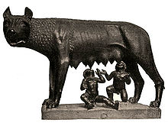Romulus wishes to build the new city on the Palatine Hill; Remus prefers the Aventine Hill. They agree to determine the site through augury. Romulus appears to receive the more favourable signs but each claims the results in his favour. In the disputes that follow, Remus is killed. [Ovid](http://en.wikipedia.org/wiki/Ovid) has Romulus invent the festival of [Lemuria](http://en.wikipedia.org/wiki/Lemuria_(festival%2529) to appease Remus' resentful ghost. Romulus names the new city [Rome](http://en.wikipedia.org/wiki/Rome), after himself, and goes on to create the [Roman Legions](http://en.wikipedia.org/wiki/Roman_Legion) and the [Roman Senate](http://en.wikipedia.org/wiki/Roman_Senate). He adds citizens to his new city by abducting the women of the neighboring [Sabine](http://en.wikipedia.org/wiki/Sabine) tribes, which results in the combination of Sabines and Romans as one Roman people. Rome rapidly expands to become a dominant force, due to divine favour and the inspired administrative, military and political leadership of Romulus. In later life Romulus becomes increasingly autocratic, disappears in mysterious circumstances and is deified as the god [Quirinus](http://en.wikipedia.org/wiki/Quirinus), the divine persona of the Roman people.

The legend of Romulus and Remus encapsulates Rome's ideas of itself, its origins, moral values and purpose: it has also been described as one of the most problematic of all foundation myths. Romulus' name is thought to be a [back-formation](http://en.wikipedia.org/wiki/Back-formation) from the name Rome; Remus' is a matter for ancient and modern speculation. The main sources for the legend approach it as history and offer an implausibly exact chronology: Roman historians dated the city's foundation variously from 758 to 728 BC. Plutarch says Romulus was fifty-three at his death; which reckoning gives the twins' birth year as c. 771 BC. Possible historical bases for the broad mythological narrative remain unclear and much disputed. Romulus and Remus are eminent among the [feral children of ancient mythography](http://en.wikipedia.org/wiki/Feral_children_in_mythology_and_fiction).

[**Caesar Flavius Valerius Aurelius Constantinus Augustus**](http://en.wikipedia.org/wiki/Constantine_I) (27 February c. 272 – 22 May 337), commonly 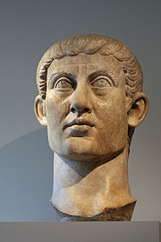known in [English](http://en.wikipedia.org/wiki/English_language) as **Constantine I**, **Constantine the Great**, or (among [Eastern Orthodox](http://en.wikipedia.org/wiki/Eastern_Orthodox_Church), Coptic Orthodox, [Oriental Orthodox](http://en.wikipedia.org/wiki/Oriental_Orthodox_Church) and [Byzantine Catholic](http://en.wikipedia.org/wiki/Byzantine_Catholic) Christians) **Saint Constantine**, was [Roman emperor](http://en.wikipedia.org/wiki/Roman_Emperor) from 306, and the undisputed holder of that office from 324 until his death in 337. Best known for being the first [Christian](http://en.wikipedia.org/wiki/Christianity) Roman emperor, Constantine reversed the [persecutions](http://en.wikipedia.org/wiki/Diocletianic_persecution) of his predecessor, [Diocletian](http://en.wikipedia.org/wiki/Diocletian), and issued (with his co-emperor [Licinius](http://en.wikipedia.org/wiki/Licinius)) the [Edict of Milan](http://en.wikipedia.org/wiki/Edict_of_Milan) in 313, which proclaimed [religious toleration](http://en.wikipedia.org/wiki/Religious_toleration) throughout the empire.

The [Byzantine](http://en.wikipedia.org/wiki/Byzantine_Rite) liturgical calendar, observed by the [Eastern Orthodox Church](http://en.wikipedia.org/wiki/Eastern_Orthodox_Church) and [Eastern Catholic Churches of Byzantine rite](http://en.wikipedia.org/wiki/Eastern_Catholic_Churches), lists both Constantine and his mother [Helena](http://en.wikipedia.org/wiki/Helena_of_Constantinople) as saints. Although he is not included in the [Latin Church's](http://en.wikipedia.org/wiki/Latin_Rite) list of saints, which does recognize several other Constantines as saints, he is revered under the title "The Great" for his contributions to [Christianity](http://en.wikipedia.org/wiki/Christianity).

Constantine also transformed the ancient Greek colony of [Byzantium](http://en.wikipedia.org/wiki/Byzantium) into a new imperial residence, [Constantinople](http://en.wikipedia.org/wiki/Constantinople), which would remain the capital of the [Byzantine Empire](http://en.wikipedia.org/wiki/Byzantine_Empire) for over one thousand years.

One of the great Roman emperors, Constantine rose to power when his father Constantius Chlorus died in the year 306 while campaigning against Scottish tribes. He later went on to defeat the rival emperor Maxentius in the decisive battle of Milvian Bridge in 312. He is credited for several great landmarks in history and is probably best memorialized by the city that bore his name for hundreds of years: Constantinople. Although now renamed Istanbul, this city was to be the seat of power for all Byzantine emperors for the next 1100 years. Constantine is also remembered as the first Roman emperor who embraced Christianity and instituted the buildings and papal dynasty that eventually grew into what is today the Vatican and the Pope.

The latter part of his life saw his commitment to the church rise in step with the increasing repression against old-school paganism. He left behind several sons who would, after his death, turn on each other and generally undo much of the stability that Constantine had fought so hard to bring about.

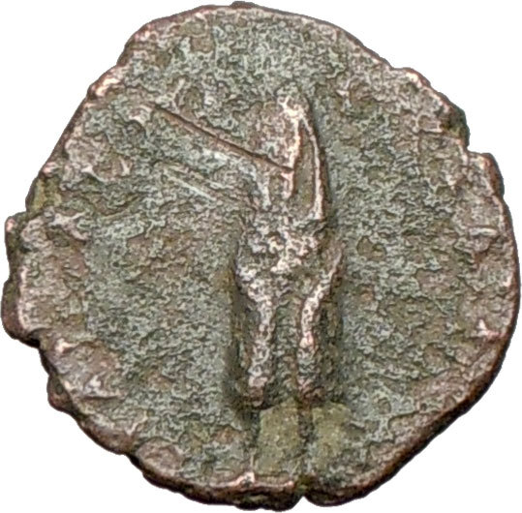 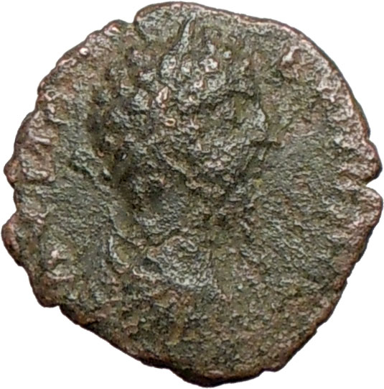

### Commodus - Roman Emperor: 177-192 A.D. - 150USD(50usd) Bronze 18mm (3.51 grams) Roman Provincial mint 177-192 A.D. Laureate, draped and cuirassed bust right. Telesphorus son of Asclepius standing facing.

You are bidding on the exact item pictured, provided with a Certificate of Authenticity and Lifetime Guarantee of Authenticity.

In [Greek mythology](http://en.wikipedia.org/wiki/Greek_mythology), **Telesphorus** (or **Telesphoros**; Τελεσφόρος) was a son of [Asclepius](http://en.wikipedia.org/wiki/Asclepius). He frequently accompanied his sister, [Hygieia](http://en.wikipedia.org/wiki/Hygieia). He was a [dwarf](http://en.wikipedia.org/wiki/Cabeiri) whose head was always covered with a [hood](http://en.wikipedia.org/wiki/Cowl) or [cap](http://en.wikipedia.org/wiki/Phrygian_cap). He symbolized recovery from illness, as his name means "the accomplisher" or "bringer of completion" in Greek. Representations of him are found mainly in [Anatolia](http://en.wikipedia.org/wiki/Anatolia) and along the [Danube](http://en.wikipedia.org/wiki/Danube).

Telesphorus is assumed to have been a [Celtic god](http://en.wikipedia.org/wiki/Celtic_god) in origin, who was taken to Anatolia by the [Galatians](http://en.wikipedia.org/wiki/Galatia) in the 3rd century BC, where he would have become associated with the Greek god of medicine, Asclepius, perhaps in [Pergamon](http://en.wikipedia.org/wiki/Pergamon), an Asclepian cult center. and spread again to the West due to the rise of the [Roman Empire](http://en.wikipedia.org/wiki/Roman_Empire), in particular during the 2nd century AD, from the reign of [Hadrian](http://en.wikipedia.org/wiki/Hadrian), after [Epidaurus](http://en.wikipedia.org/wiki/Epidaurus), the main center of the cult of Asclepius, had adopted him.

**Asclepius** is the god of [medicine](http://en.wikipedia.org/wiki/Medicine) and healing in ancient [Greek religion](http://en.wikipedia.org/wiki/Religion_in_ancient_Greece). Asclepius represents the healing aspect of the medical arts; his daughters are [Hygieia](http://en.wikipedia.org/wiki/Hygieia) ("Health"), [Iaso](http://en.wikipedia.org/wiki/Iaso) ("Medicine"), [Aceso](http://en.wikipedia.org/wiki/Aceso) ("Healing"), [Aglæa/Ægle](http://en.wikipedia.org/wiki/Aglaea) ("Healthy Glow"), and [Panacea](http://en.wikipedia.org/wiki/Panacea) ("Universal Remedy"). The [rod of Asclepius](http://en.wikipedia.org/wiki/Rod_of_Asclepius), a snake-entwined staff, remains a symbol of medicine today, although sometimes the [caduceus](http://en.wikipedia.org/wiki/Caduceus), or staff with two snakes, is mistakenly used instead. He was associated with the Roman/Etruscan god [Vediovis](http://en.wikipedia.org/wiki/Vediovis). He was one of [Apollo](http://en.wikipedia.org/wiki/Apollo)'s servants.

The **rod of Asclepius**, also known as the **asklepian**, is an ancient symbol associated with [astrology](http://en.wikipedia.org/wiki/Astrology), the [Greek](http://en.wikipedia.org/wiki/Greece) [god](http://en.wikipedia.org/wiki/God) [Asclepius](http://en.wikipedia.org/wiki/Asclepius) and with [medicine](http://en.wikipedia.org/wiki/Medicine) and [healing](http://en.wikipedia.org/wiki/Healing). It consists of a [serpent](http://en.wikipedia.org/wiki/Serpent_(symbolism%2529) entwined around a [staff](http://en.wikipedia.org/wiki/Staff_(stick%2529). The name of the symbol derives from its early and widespread association with [Asclepius](http://en.wikipedia.org/wiki/Asclepius), the son of [Apollo](http://en.wikipedia.org/wiki/Apollo), who was a practitioner of medicine in ancient [Greek mythology](http://en.wikipedia.org/wiki/Greek_mythology). His attributes, the snake and the staff, sometimes depicted separately in antiquity, are combined in this symbol. The Rod of Asclepius also represents the constellation [Ophiuchus](http://en.wikipedia.org/wiki/Ophiuchus) (or Ophiuchus Serpentarius), the thirteenth sign of the [sidereal zodiac](http://en.wikipedia.org/wiki/Sidereal_zodiac). [Hippocrates](http://en.wikipedia.org/wiki/Hippocrates) himself was a worshipper of Asclepius.

[**Lucius Aurelius Commodus Antoninus**](http://en.wikipedia.org/wiki/Commodus) (31 August 161 – 31 December 192) was a [Roman Emperor](http://en.wikipedia.org/wiki/Roman_Emperor) who ruled from 180 to 192 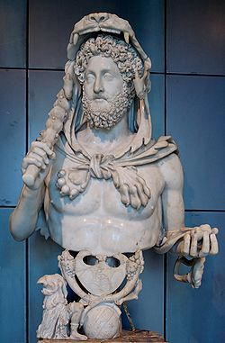(also with his father, [Marcus Aurelius](http://en.wikipedia.org/wiki/Marcus_Aurelius), from 177 until 180). The name given here was his official name at his accession to sole rule; see [Changes of name](http://en.wikipedia.org/wiki/Commodus" \l "Changes_of_name) for earlier and later forms. His accession as emperor was the first time a son had succeeded his father since [Titus](http://en.wikipedia.org/wiki/Titus) succeeded [Vespasian](http://en.wikipedia.org/wiki/Vespasian) in 79. Commodus was the first emperor "[born to the purple](http://en.wikipedia.org/wiki/Born_in_the_purple)"; i.e., born during his father's reign.

Commodus vies with Caligula and Nero as Roman history's most perverse and sadistic of rulers. Like Caligula and Nero before, Commodus was an ordinary (by imperial standards) ruler who succeeded Marcus Aurelius, his father, upon his death. In his one major positive deed, Commodus called off the expedition against the Germans which his father had commenced on terms favorable to Rome. He sped off to Rome where he much preferred living the perks of an emperor to the dirty business of waging wars. While he whiled away his time pursuing a hedonistic lifestyle he was happy to delegate administrative responsibilities to others.

Unfortunately, his appointees never seemed to last long on the job. Whether through incompetence, bad luck or corruption, one by one these fell and needed replacement. Commodus little by little began gaining a taste for power as the shuffling of his foremen took place and, finally, he decided to manage the empire himself. It is starting with this period that Commodus began to act increasingly unpredictably and cruel. A botched conspiracy against him, orchestrated by no less than his beloved sister Lucilla, was discovered and his surviving the episode turned him afterwards into a highly paranoid individual who had countless officials executed for disloyalty imagined or real.

In his final year of life he shocked Romans of all classes by personally moonlighting as a gladiator. Of course, these fights were arranged so that he could invariably come out the victor. Because of this a record-breaking 700+ victories were scored in his name, each one ending in the deaths of one or more gladiators and/or wild beasts at the Colosseum. A successful conspiracy against him was finally hatched by one of his lovers who first tried poisoning him but he threw up and a wrestler was summoned who strangled him to death on the last day of the year 192.

The recent Hollywood release "The Gladiator" is a fictionalized account of Commodus as emperor which has him at odds with a popular gladiator.

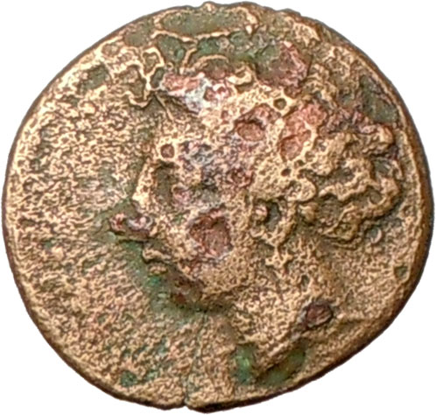 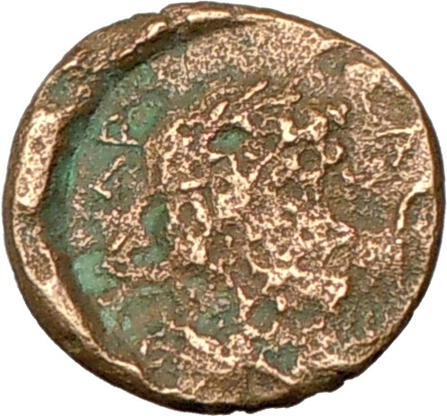

**Greek city of Larissa in Thessaly 200USD (60 usd)**Bronze 15mm (3.47 grams) Struck 380-337 B.C.  
Reference: Rogers 305;SNGCop 146   
Head of the nymph Larissa left.  
ΛΑΡΙΣΑ, Laureate head of Asclepius right; serpent before.

\* Numismatic Note: This is the first time that this type from Larissa has come across my hands in my whole lifetime. Very rare.

 You are bidding on the exact item pictured, provided with a Certificate of Authenticity and Lifetime Guarantee of Authenticity.

**Asclepius** is the god of [medicine](http://en.wikipedia.org/wiki/Medicine) and healing in ancient [Greek religion](http://en.wikipedia.org/wiki/Religion_in_ancient_Greece). Asclepius represents the healing aspect of the medical arts; his daughters are [Hygieia](http://en.wikipedia.org/wiki/Hygieia) ("Health"), [Iaso](http://en.wikipedia.org/wiki/Iaso) ("Medicine"), [Aceso](http://en.wikipedia.org/wiki/Aceso) ("Healing"), [Aglæa/Ægle](http://en.wikipedia.org/wiki/Aglaea) ("Healthy Glow"), and [Panacea](http://en.wikipedia.org/wiki/Panacea) ("Universal Remedy"). The [rod of Asclepius](http://en.wikipedia.org/wiki/Rod_of_Asclepius), a snake-entwined staff, remains a symbol of medicine today, although sometimes the [caduceus](http://en.wikipedia.org/wiki/Caduceus), or staff with two snakes, is mistakenly used instead. He was associated with the Roman/Etruscan god [Vediovis](http://en.wikipedia.org/wiki/Vediovis). He was one of [Apollo](http://en.wikipedia.org/wiki/Apollo)'s servants.

The **rod of Asclepius**, also known as the **asklepian**, is an ancient symbol associated with [astrology](http://en.wikipedia.org/wiki/Astrology), the [Greek](http://en.wikipedia.org/wiki/Greece) [god](http://en.wikipedia.org/wiki/God) [Asclepius](http://en.wikipedia.org/wiki/Asclepius) and with [medicine](http://en.wikipedia.org/wiki/Medicine) and [healing](http://en.wikipedia.org/wiki/Healing). It consists of a [serpent](http://en.wikipedia.org/wiki/Serpent_(symbolism%2529) entwined around a [staff](http://en.wikipedia.org/wiki/Staff_(stick%2529). The name of the symbol derives from its early and widespread association with [Asclepius](http://en.wikipedia.org/wiki/Asclepius), the son of [Apollo](http://en.wikipedia.org/wiki/Apollo), who was a practitioner of medicine in ancient [Greek mythology](http://en.wikipedia.org/wiki/Greek_mythology). His attributes, the snake and the staff, sometimes depicted separately in antiquity, are combined in this symbol. The Rod of Asclepius also represents the constellation [Ophiuchus](http://en.wikipedia.org/wiki/Ophiuchus) (or Ophiuchus Serpentarius), the thirteenth sign of the [sidereal zodiac](http://en.wikipedia.org/wiki/Sidereal_zodiac). [Hippocrates](http://en.wikipedia.org/wiki/Hippocrates) himself was a worshipper of Asclepius.

Larissa, sometimes written Larisa on ancient coins and inscriptions, is near the site of the Homeric Argissa. It appears in early times, when [Thessaly](http://en.wikipedia.org/wiki/Thessaly) was mainly governed by a few aristocratic families, as an important city under the rule of the [Aleuadae](http://en.wikipedia.org/wiki/Aleuadae), whose authority extended over the whole district of [Pelasgiotis](http://en.wikipedia.org/wiki/Pelasgiotis). This powerful family possessed for many generations before 369 BC the privilege of furnishing the *tagus*, the local term for the [*strategos*](http://en.wikipedia.org/wiki/Strategos) of the combined Thessalian forces. The principal rivals of the Aleuadae were the [Scopadac](http://en.wikipedia.org/w/index.php?title=Scopadac&action=edit&redlink=1) of [Crannon](http://en.wikipedia.org/wiki/Crannon), the remains of which (called by the Turks Old Larissa) are about 14 miles south west. The inhabitants sided with [Athens](http://en.wikipedia.org/wiki/Athens) during the Peloponnesian War.

As the chief city of ancient Thessaly, Larissa was directly annexed by Philip II of Macedon in 344, and from then on Larissa was under Macedonian control; in 196 B.C. Larissa became an ally of Rome and was the headquarters of the [Thessalian League](http://en.wikipedia.org/wiki/Thessalian_League).

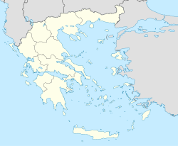



Larissa

[Coordinates](http://en.wikipedia.org/wiki/Geographic_coordinate_system) [39°38.5′N 22°25′E](http://stable.toolserver.org/geohack/geohack.php?pagename=Larissa&params=39_38.5_N_22_25_E_type:city(126076)_region:GR-42)

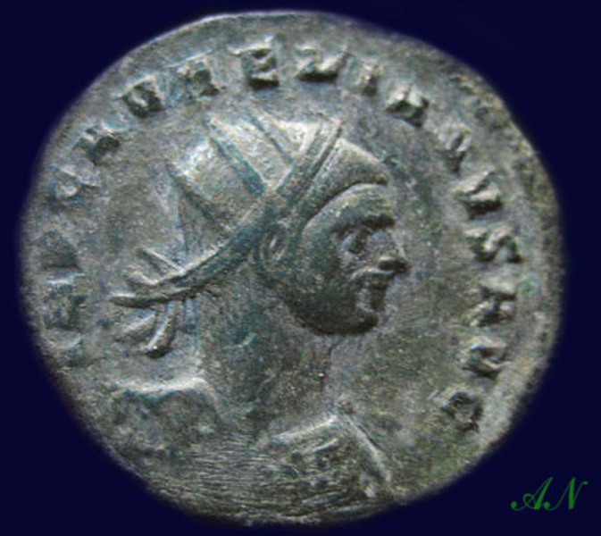 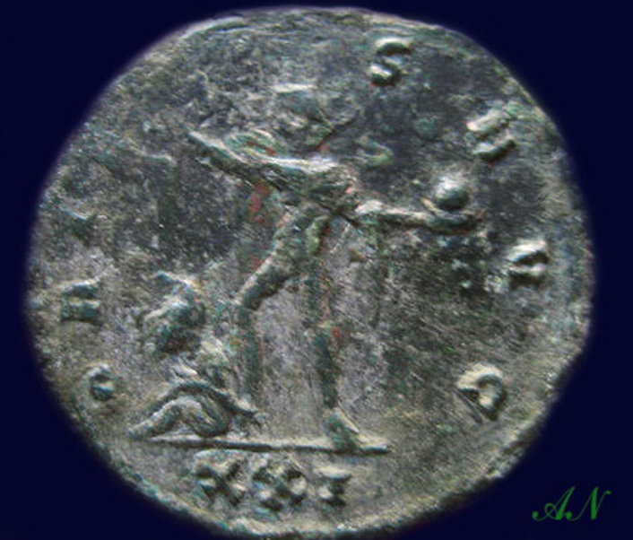 IMP C AVRELIANVS AVG, Radiate cuirassed bust right. 13usd

ORIENS AVG Sol standing right, head turned back,

right hand raised, holding globe, captive seated to left.

XXI in ex.

**22mm 3,79gr** 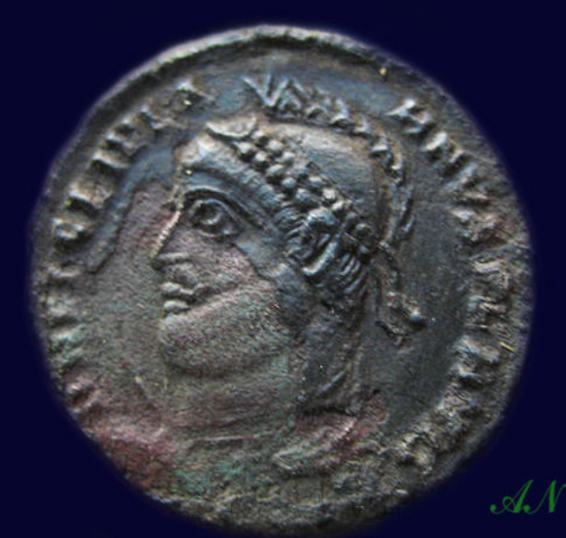 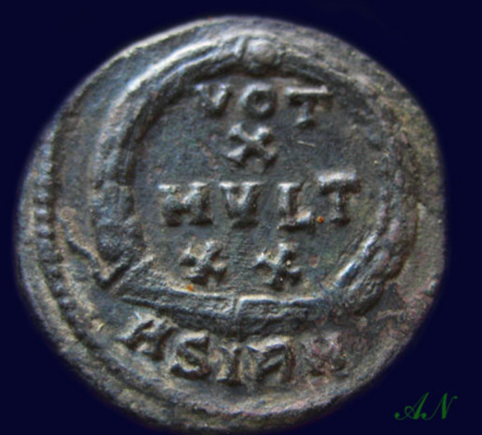 Julian II the Apostate AE3. 360-363 AD. D N FL CL IVLIANVS P F AVG, helmeted, cuirassed bust left holding spear & sheild / VOT X MVLT XX in wreath. ASIRM in ex.Sirmium mint.

20mm 2,94gr

24usd

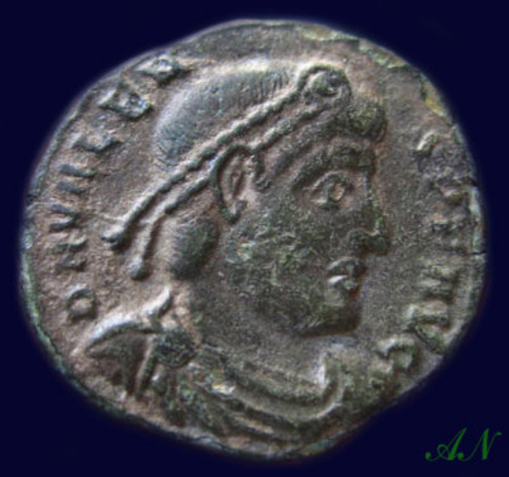 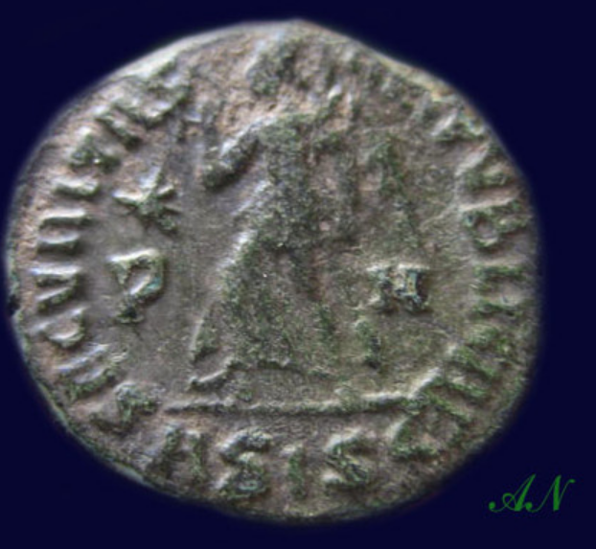 Valens AE3 "Victory" Valens AD 364-378 AE3

Obv: D N VALENS P F AVG - Diademed bust right, draped and cuirassed. Rev: SECVRITAS REIPVBLICAE - Victory advancing left, holding wreath, and palm. Exe: ASISC Siscia mint,Star over P in left,N in right field .

**17mm 1,67gr**

2usd!

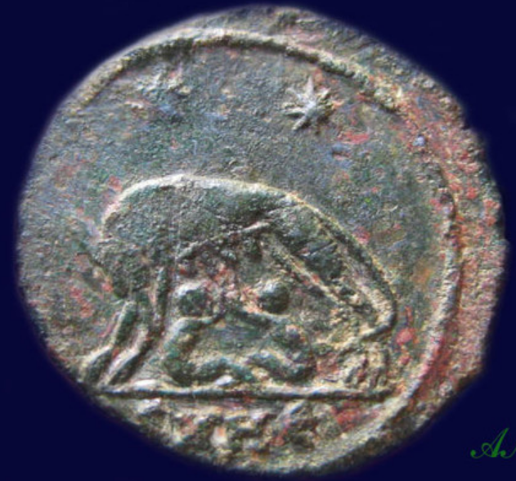 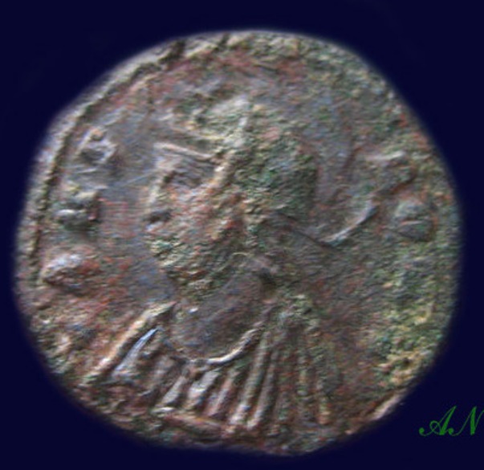 Urbs Roma AE3 "Wolf and twins" VRBS ROMA, helmeted bust of Roma left, wearing imperial mantle.No legend, she-wolf & twins Romulus & Remus, two stars above.SMHE in ex.HERACLEA mint.18mm 2,67gr

3usd! 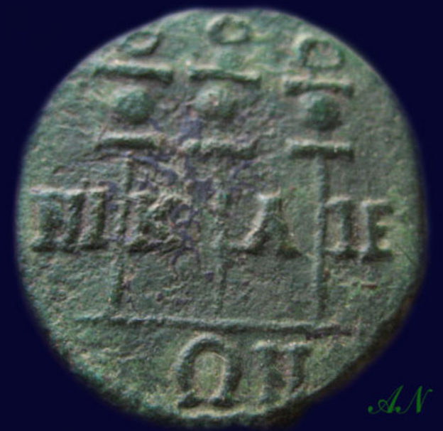 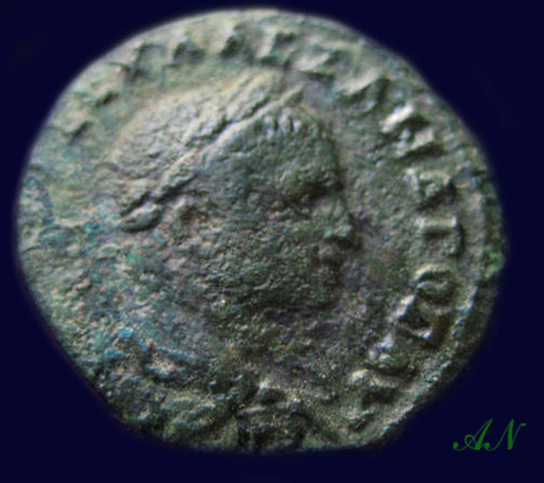 M.AV.CEV.ALEXANDPOC AV, His radiated draped cuirassed bust right,

NI K A IE ON between three standards.

**19mm 4,83gr**

3usd!

**highrating\_lowprice**

[**Member id** highrating\_lowprice](http://myworld.ebay.com/highrating_lowprice/&_trksid=p3984.m1439.l2754) | [**Feedback Score Of** 10227](http://feedback.ebay.com/ws/eBayISAPI.dll?ViewFeedback2&userid=highrating_lowprice&_trksid=p3984.m1439.l2776) | 100.0%

**Total items :** 4

$305.00

+$10.50

|  |
| --- |
| [**View order details**](http://payments.ebay.com/ws/eBayISAPI.dll?ViewPaymentStatus&transId=714338865013&ssPageName=STRK:MEWNX:VPS&itemid=230603075373&_trksid=p3984.m1439.l2673) |
| [Contact seller](http://contact.ebay.com/ws/eBayISAPI.dll?ShowSellerFAQ&iid=230603075373&ssPageName=STRK:MEWNX:SCI&redirect=0&requested=highrating_lowprice&_trksid=p3984.m1439.l2652) |
| [More actions](javascript:;) |

**FAUSTA wife of CONSTANTINE I the GREAT Authentic Ancient Roman Coin SALUS Health**

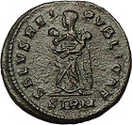

[FAUSTA wife of CONSTANTINE I the GREAT Authentic Ancient ...](http://www.ebay.com/itm/230603075373?ssPageName=STRK:MEWNX:IT&_trksid=p3984.m1439.l2649) (230603075373)

Sale date: 05/08/12

Tracking number: [9402111201080504088596](javascript:;)

Estimated Delivery: 05/10/12 - 05/16/12

$100.00

$250.00

**(60% off)**

+ $4.50

shipping

**Paid with PayPal on May 08, 2012.**

**Shipped 05/08/12**

**Feedback not left**

**Positive feedback received**

|  |
| --- |
| [**View order details**](http://payments.ebay.com/ws/eBayISAPI.dll?ViewPaymentStatus&transId=714338865013&ssPageName=STRK:MEWNX:VPS&itemid=230603075373&_trksid=p3984.m1439.l2673) |
| [Leave feedback](http://feedback.ebay.com/ws/eBayISAPI.dll?LeaveFeedbackShow&useridto=highrating_lowprice&item=230603075373&transactID=714338865013&ssPageName=STRK:MEWNX:LF&_trksid=p3984.m1439.l2665) |
| [More actions](javascript:;) |

**CLAUDIUS II 268AD Ancient Authentic Genuine Roman Coin SALUS HEALTH**

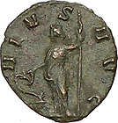

[CLAUDIUS II 268AD Ancient Authentic Genuine Roman Coin S...](http://www.ebay.com/itm/230613430874?ssPageName=STRK:MEWNX:IT&_trksid=p3984.m1439.l2649) (230613430874)

Sale date: 05/08/12

Tracking number: [9402111201080504088596](javascript:;)

Estimated Delivery: 05/10/12 - 05/16/12

$40.00

$100.00

**(60% off)**

+ $4.50

shipping

**Paid with PayPal on May 08, 2012.**

**Shipped 05/08/12**

**Feedback not left**

**Positive feedback received**

|  |
| --- |
| [**View order details**](http://payments.ebay.com/ws/eBayISAPI.dll?ViewPaymentStatus&transId=714317197013&ssPageName=STRK:MEWNX:VPS&itemid=230613430874&_trksid=p3984.m1439.l2673) |
| [Leave feedback](http://feedback.ebay.com/ws/eBayISAPI.dll?LeaveFeedbackShow&useridto=highrating_lowprice&item=230613430874&transactID=714317197013&ssPageName=STRK:MEWNX:LF&_trksid=p3984.m1439.l2665) |
| [More actions](javascript:;) |

**FAUSTA 2nd wife Constantine I the Great 326AD Authentic Ancient Roman Coin SALUS**

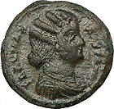

[FAUSTA 2nd wife Constantine I the Great 326AD Authentic A...](http://www.ebay.com/itm/230655501358?ssPageName=STRK:MEWNX:IT&_trksid=p3984.m1439.l2649) (230655501358)

Sale date: 05/08/12

Tracking number: [9402111201080504088596](javascript:;)

Estimated Delivery: 05/10/12 - 05/16/12

$40.00

$100.00

**(60% off)**

+ $4.50

shipping

**Paid with PayPal on May 08, 2012.**

**Shipped 05/08/12**

**Feedback not left**

**Positive feedback received**

|  |
| --- |
| [**View order details**](http://payments.ebay.com/ws/eBayISAPI.dll?ViewPaymentStatus&transId=714335452013&ssPageName=STRK:MEWNX:VPS&itemid=230655501358&_trksid=p3984.m1439.l2673) |
| [Leave feedback](http://feedback.ebay.com/ws/eBayISAPI.dll?LeaveFeedbackShow&useridto=highrating_lowprice&item=230655501358&transactID=714335452013&ssPageName=STRK:MEWNX:LF&_trksid=p3984.m1439.l2665) |
| [More actions](javascript:;) |

**SEPTIMIUS SEVERUS 193AD Nicopolis Rare Ancient Roman Coin Asclepius TEMPLE**

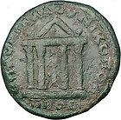

[SEPTIMIUS SEVERUS 193AD Nicopolis Rare Ancient Roman Coin...](http://www.ebay.com/itm/320799433260?ssPageName=STRK:MEWNX:IT&_trksid=p3984.m1439.l2649) (320799433260)

Sale date: 05/08/12

Tracking number: [9402111201080504088596](javascript:;)

Estimated Delivery: 05/10/12 - 05/16/12

$125.00

$400.00

**(68% off)**

+ $4.50

shipping

**Paid with PayPal on May 08, 2012.**

**Shipped 05/08/12**

**Feedback not left**

**Positive feedback received**

|  |
| --- |
| [**View order details**](http://payments.ebay.com/ws/eBayISAPI.dll?ViewPaymentStatus&transId=890425423011&ssPageName=STRK:MEWNX:VPS&itemid=320799433260&_trksid=p3984.m1439.l2673) |
| [Leave feedback](http://feedback.ebay.com/ws/eBayISAPI.dll?LeaveFeedbackShow&useridto=highrating_lowprice&item=320799433260&transactID=890425423011&ssPageName=STRK:MEWNX:LF&_trksid=p3984.m1439.l2665) |
| [More actions](javascript:;) |

**Warring-States Bronze Mirror 4 Pictured 'Mountain's**

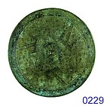

[Warring-States Bronze Mirror 4 Pictured 'Mountain's](http://www.ebay.com/itm/110850819937?ssPageName=STRK:MEWNX:IT&_trksid=p3984.m1439.l2649) (110850819937)

Sale date: 05/11/12

Tracking number: --

Estimated Delivery: 06/12/12 - 06/25/12

$315.00

+ $12.00

shipping

**Paid with PayPal on May 11, 2012.**

**Not shipped**

**Feedback not left**

**Feedback not received**

|  |
| --- |
| [**Leave feedback**](http://feedback.ebay.com/ws/eBayISAPI.dll?LeaveFeedbackShow&useridto=milangubi2006&item=110850819937&transactID=841768449001&ssPageName=STRK:MEWNX:LF&_trksid=p3984.m1439.l2665) |
| [Contact seller](http://contact.ebay.com/ws/eBayISAPI.dll?ShowSellerFAQ&iid=110850819937&ssPageName=STRK:MEWNX:SCI&redirect=0&requested=milangubi2006&_trksid=p3984.m1439.l2652) |
| [More actions](javascript:;) |

**Tang Dynasty Bronze Mirror Ancient Marks & Words 130mm!**

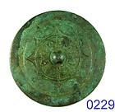

[Tang Dynasty Bronze Mirror Ancient Marks & Words 130mm!](http://www.ebay.com/itm/110834734109?ssPageName=STRK:MEWNX:IT&_trksid=p3984.m1439.l2649) (110834734109)

Sale date: 05/04/12

Tracking number: --

Estimated Delivery: 06/05/12 - 06/18/12

$338.00

+ $15.00

shipping

**Paid with PayPal on May 04, 2012.**

**Not shipped**

**Feedback not left**

**Feedback not received**

|  |
| --- |
| [**Leave feedback**](http://feedback.ebay.com/ws/eBayISAPI.dll?LeaveFeedbackShow&useridto=milangubi2006&item=110834734109&transactID=838018217001&ssPageName=STRK:MEWNX:LF&_trksid=p3984.m1439.l2665) |
| [Contact seller](http://contact.ebay.com/ws/eBayISAPI.dll?ShowSellerFAQ&iid=110834734109&ssPageName=STRK:MEWNX:SCI&redirect=0&requested=milangubi2006&_trksid=p3984.m1439.l2652) |
| [More actions](javascript:;) |

**RARE CHINESE BRONZE MIRROR**

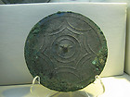

[RARE CHINESE BRONZE MIRROR](http://www.ebay.com/itm/251023137458?ssPageName=STRK:MEWNX:IT&_trksid=p3984.m1439.l2649) (251023137458)

Sale date: 05/03/12

Tracking number: --

Estimated Delivery: 05/21/12 - 06/04/12

$399.00

Free

shipping

**Paid with PayPal on May 03, 2012.**

**Shipped 05/04/12**

**Feedback not left**

**Feedback not received**

|  |
| --- |
| [**Leave feedback**](http://feedback.ebay.com/ws/eBayISAPI.dll?LeaveFeedbackShow&useridto=yangxin_ya&item=251023137458&transactID=998644741015&ssPageName=STRK:MEWNX:LF&_trksid=p3984.m1439.l2665) |
| [Contact seller](http://contact.ebay.com/ws/eBayISAPI.dll?ShowSellerFAQ&iid=251023137458&ssPageName=STRK:MEWNX:SCI&redirect=0&requested=yangxin_ya&_trksid=p3984.m1439.l2652) |
| [More actions](javascript:;) |

**JAPANESE SAMURAI PERIOD BRONZE MIRROR**

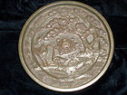

[JAPANESE SAMURAI PERIOD BRONZE MIRROR](http://www.ebay.com/itm/260997223099?ssPageName=STRK:MEWNX:IT&_trksid=p3984.m1439.l2649) (260997223099)

Sale date: 04/28/12

Tracking number: [9105128882300304320069](javascript:;)

Estimated Delivery: 05/03/12 - 05/04/12

$399.00

+ $6.35

shipping

**Paid with PayPal on April 28, 2012.**

**Shipped 04/29/12**

**Feedback not left**

**Positive feedback received**

|  |
| --- |
| [**View order details**](http://payments.ebay.com/ws/eBayISAPI.dll?ViewPaymentStatus&transId=974557407016&ssPageName=STRK:MEWNX:VPS&itemid=260997223099&_trksid=p3984.m1439.l2673) |
| [Leave feedback](http://feedback.ebay.com/ws/eBayISAPI.dll?LeaveFeedbackShow&useridto=joeperadua&item=260997223099&transactID=974557407016&ssPageName=STRK:MEWNX:LF&_trksid=p3984.m1439.l2665) |
| [More actions](javascript:;) |